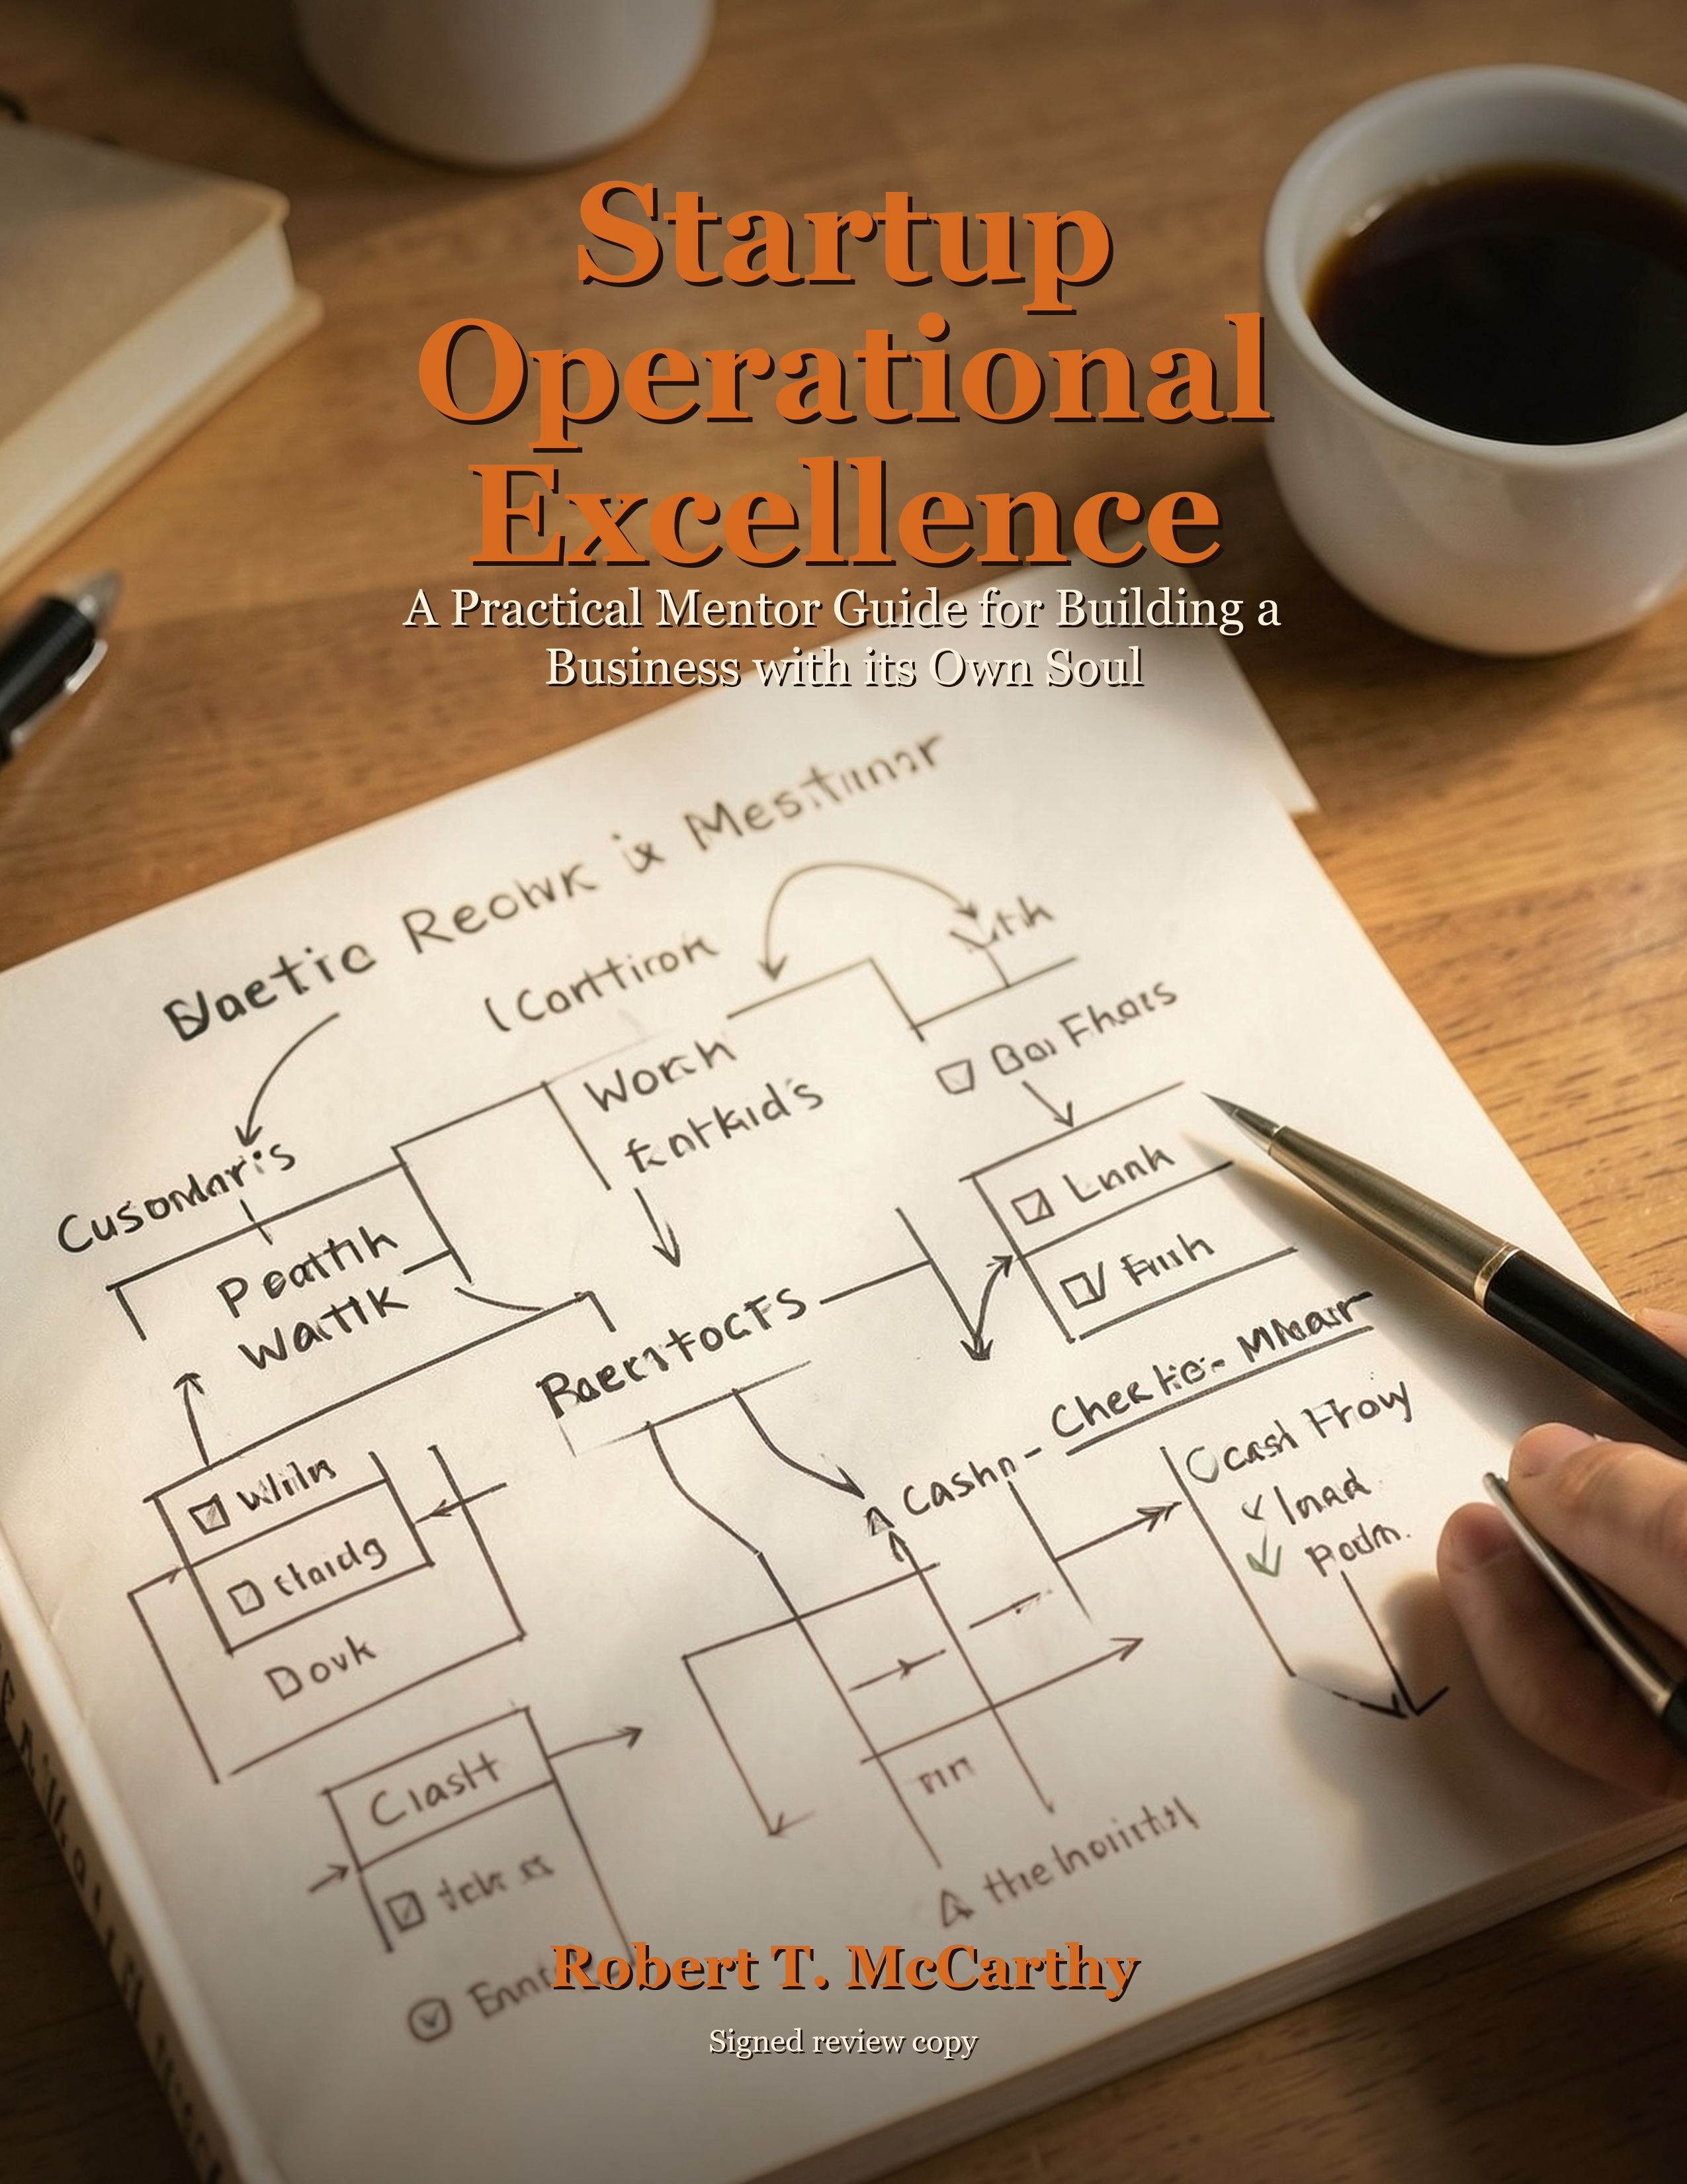

Startup Operational Excellence
A Practical Mentor Guide for Building a Business with its Own Soul
Robert T. McCarthy
Uncle Robert Consulting LLC
Draft review edition

Copyright And Use Notice
Copyright 2026 Robert T. McCarthy. All rights reserved.
This draft is provided for review and editorial feedback. No part of this work
should be reproduced, distributed, or sold without written permission from the
author or Uncle Robert Consulting LLC.
This book provides general business education and operational guidance. It is
not legal, financial, tax, investment, or compliance advice. Founders should
consult qualified professionals for decisions that require licensed judgment.

Disclosure Notes
The founder scenes in this book use Sam as a composite character. They are
designed to teach practical lessons without exposing private client details.
This book was developed with AI-assisted drafting and editing under Robert T. McCarthy's direction. The ideas, judgment, voice, final editorial decisions,
and responsibility for the work remain with the author.
Some graphics or visual aids in this book may be AI-assisted. They are used to
clarify concepts, not to represent real clients, private business records, or
documented case results unless explicitly stated.

How To Use This Book
This book is meant to be read like a mentor conversation and used like a field
guide.
You do not have to fix everything at once. In fact, trying to fix everything
at once is one of the ways founders stay stuck. Read for clarity first. Mark
the places where your business feels familiar. When a chapter gives you a
checkpoint, choose one visible improvement and make that improvement real.
The appendices at the back are not homework for perfectionists. They are tools
for founders who need a place to start. Use them when the story names a
problem you recognize and you are ready to turn that recognition into action.

Contents
Foreword: Hey Partner, Let Us Start With the Real Problem
Introduction: The Business Is Already Speaking
Chapter 1: Understanding the Business You Are Actually Running
Chapter 2: Removing the Weight from the Work
Chapter 3: People, Time, and Tools Are Not Infinite
Chapter 4: Profit Is a Practice
Chapter 5: Building a Company That Learns
Chapter 6: The Rhythm That Keeps the Business Alive
Chapter 7: Building a Business That Can Be Trusted
Chapter 8: The Founder Becomes the Steward
Conclusion: Build the System That Lets the Promise Live
Appendix A: Operational Audit Question Bank
Appendix B: Workflow Mapping Worksheet
Appendix C: Resource Allocation Scorecard
Appendix D: Tool Spend Review Checklist
Appendix E: Cost And Profitability Review Sheet
Appendix F: Root Cause Analysis Worksheet
Appendix G: SOP Update Checklist

Foreword: Hey Partner, Let Us Start With the Real Problem
Hey partner, let us start with something honest: most businesses do not get messy because the owner does not care. They get messy because the owner cares about everything at once.
You care about the customer who needs an answer. You care about the invoice that has to go out. You care about the employee who is trying but still needs direction. You care about the tool you bought because it was supposed to make life easier, only now it has become one more place to check. You care about growth, but you also care about not losing yourself in the process of trying to grow.
I have worn a lot of hats in my life: manager, teacher, preacher, pastor, coach, mentor, dad, uncle, consultant, builder, and student of my own mistakes. One thing those roles have taught me is that people usually do not need someone to stand far away and tell them what is wrong. They need someone willing to sit beside them, look at the real situation, and say, "All right. Let us figure this out together."
That is the spirit of this book. We are not chasing operational excellence because it sounds impressive. We are chasing it because better operations give people room to breathe. They protect trust. They reduce confusion. They help a business keep its promises without asking the owner to become the emergency backup plan for every broken process.
I also want to be clear about something: I do not believe good business systems are built once and worshiped forever. We learn. We grow. We update. We do things differently now than we did before because we have more clarity than we had before. That is not inconsistency. That is truthfulness in motion. A living business has to be allowed to mature.
So if you are reading this with a tired mind and a full plate, I am not here to shame you with another list of what you should have done already. I am here to walk through the work with you. Step by step. Process by process. Decision by decision. We are going to build clarity, and we are going to do it in a way you can actually use.

Introduction: The Business Is Already Speaking
Every business is already telling the truth about itself. The question is whether we have slowed down enough to listen.
The truth may show up as a customer waiting too long for a response. It may show up as a team member asking the same question three weeks in a row because the answer was never written down. It may show up as a stack of tools that were bought with hope but never turned into a working system. It may show up as the owner feeling like they are the only one who knows how everything connects.
When those things happen, the easy answer is to say, "We need to work harder." Sometimes effort is part of the answer. But many times the deeper issue is not effort. It is structure. The people are moving, but the system is not helping them move in the same direction.
Operational excellence is not about making a business cold or mechanical. At its best, it is a servant-leadership practice. It asks: how can we use process, technology, documentation, and discipline to make people more capable? How can we reduce the burden on the owner? How can we help the customer experience more consistency? How can we build something that can keep learning as the business grows?
That last part matters. We are not building a museum. We are building an operating system that can be updated. When new truth shows up, we do not hide it to protect our pride. We update the process. We update the SOP. We update the playbook. We update the offer. We update because sincerity requires us to let the record catch up with reality.
This book follows a simple path. First, we learn to see the business clearly. Then we remove unnecessary weight from the work. Then we manage time, people, tools, and money with more discipline. Finally, we build a culture that can keep improving without turning every improvement into a crisis.
If that sounds practical, good. It should. The goal is not to impress you. The goal is for you to finish each section with a clearer next step than you had when you started.

Chapter 1: Understanding the Business You Are Actually Running
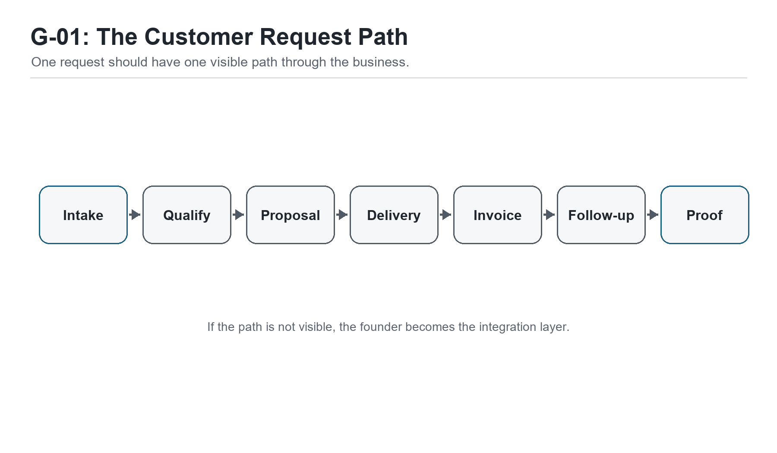
Figure G-01. The Customer Request Path. One request should have one visible path through the business.
Hey partner, before we fix anything, we have to be honest about what we are looking at. That sounds simple, but it is one of the hardest moves in business. Most of us are much better at working inside the business than standing back and seeing the business clearly.
Sam had that problem. He was not lazy. He was not careless. He had started a small service business with a real skill, real customers, and a real desire to do good work. The trouble was that the business had grown just enough to become confusing. Not big, exactly. Just heavier than it used to be.
When Sam first sat down with me, he had the look I have seen on a lot of founders. He was hopeful, but tired. He had a notebook, a phone full of reminders, a laptop with too many browser tabs open, and a list of tools he had tried because each one promised to make the business easier. One tool held contacts. Another held invoices. Another was supposed to manage projects. A spreadsheet tracked some leads, but not all of them. A few important details still lived in text messages. Some things lived only in Sam's head.
He told me, 'I think I need better systems.' That was true, but it was also too broad to help him yet. When a founder says, 'I need better systems,' what they usually mean is, 'I am tired of carrying the whole business in my memory.' That is a different kind of problem. It is not just a tool problem. It is an operating clarity problem.
So I did not start by asking Sam what software he wanted to use. I asked him to walk me through one real customer request. Not the whole company. Not the five-year vision. One customer request from beginning to end. Where does it start? Who sees it first? Where does the information go? What happens next? What happens if you are busy? What happens if the customer follows up before you do?
Sam smiled at first because the question sounded easy. Then he paused. That pause told us something. The business already had a process, but the process was not written, visible, or reliable. It existed as a trail of habits, memory, effort, and improvisation. That is how many small businesses begin. It is not a moral failure. It is a growth stage.
Most owners know their business from the inside. They know the customers. They know the pressure. They know who always answers the phone, which vendor is reliable, which client needs extra care, which employee is good with details, which tool is annoying, and which process only works because one person remembers the missing step. That kind of knowledge is valuable. It is also dangerous if it never becomes visible.
Inside knowledge helps you survive the day. An operating picture helps you build a business that does not have to survive every day by force of memory and willpower.
This is where the operational audit comes in. Now, I know the word audit can sound heavy. It can sound like someone is coming in with a clipboard to tell you everything you did wrong. That is not how I want you to think about it. In this book, an audit is not an accusation. It is a flashlight.
We are simply shining light on how the work moves. We are looking at the path between promise and delivery. We are asking where the work begins, where it waits, who touches it, what tool holds it, where decisions are made, where money is delayed, and where customer trust is either strengthened or strained.
The first rule of this kind of audit is that we do not judge the business before we understand it. If the intake starts in a text message, say that. If the quote gets built from an old email, say that. If the project is tracked in Sam's head until the deadline gets close, say that too. We cannot improve a pretend process. We can only improve the process that actually exists.
Sam's first instinct was to explain what the process was supposed to be. That is normal. Most of us want to present the best version of our work, especially when someone else is looking. But operational excellence does not begin with the polished version. It begins with the honest version.
So we slowed down. We chose one recent customer request and followed it like a string through the business. The lead came from a referral. Sam received it as a text message. He replied quickly, which was good. Then he copied the name into a note app because he was away from his desk. Later, he meant to add the person to the spreadsheet, but another client called. The next morning, he sent a proposal from a previous template, but he had to rewrite the scope because the service had changed. The customer asked a question by email. Sam answered from his phone. The final agreement happened, but the invoice was created two days later because invoicing was not connected to the proposal step.
Nothing in that story is dramatic. That is exactly why it matters. Operational problems rarely announce themselves with thunder. They usually show up as small delays, repeated questions, missing details, extra effort, and a founder feeling like he should have remembered something sooner.
When we finished walking the request, Sam said, 'I did not realize how many places one customer goes.' That sentence was the beginning of clarity. The customer had traveled through text messages, notes, email, a proposal template, memory, and an invoice system before the work even started. The business was not one system. It was a collection of islands connected by Sam's attention.
That is where a lot of small businesses are. Too many tools and too little clarity. The tools are not always bad. Some of them may be useful. But if the work does not have a clear path, the tools cannot save it. They can only hold fragments of it.
Let us make this practical: follow one customer request
Choose one real customer request from the last two weeks and trace it from first contact to final outcome. Do not clean it up first. Write what actually happened.
Where did the request first arrive?
Who saw it first?
Where was the information recorded?
What tool or person carried it to the next step?
Where did it wait?
Where did Sam, or the owner, have to remember something manually?
When did the customer next hear from the business?
When did money enter the process?

Once the first path is visible, we can widen the view. Every business has several core areas that deserve attention. We do not have to audit them all in one exhausting week, but we do need to know they exist. The business is an ecosystem. Sales affects delivery. Delivery affects billing. Billing affects cash. Cash affects decisions. Customer service affects referrals. Internal communication affects all of it.
The first area is production or service delivery. For a service business like Sam's, this means the actual path from agreement to fulfilled promise. How is the client onboarded? How is the work scheduled? Who does the work? What standard defines a finished job? What happens if the client changes scope? Where is quality checked? If the work depends on Sam personally reviewing everything at the last minute, that is not a delivery system. That is Sam acting as the system.
The second area is sales and marketing operations. How do people find the business? Where do leads come from? What happens when someone shows interest? How quickly does the business respond? What information is captured? How are leads followed up? A lot of founders think they have a marketing problem when they really have a follow-up problem. The market may be giving them signals, but the business has no consistent way to receive, sort, and respond to those signals.
The third area is administration and back office. This is the work that rarely gets applause but keeps the business alive: finance, invoicing, records, scheduling, tool access, contracts, files, passwords, and documentation. When back-office work is weak, the front of the business feels it. Customers may not see the spreadsheet, but they feel the delay. They may not know the invoice process, but they feel the confusion when terms are unclear.
The fourth area is customer service and support. How does the business handle questions, complaints, changes, and feedback after the sale? A small business often wins because it feels personal. That personal touch is a strength, but it needs support. If customers can only get good service when the owner personally remembers every detail, the business has not built service. It has built dependence.
The fifth area is internal communication and workflow. This is where many small teams quietly struggle. The work may be happening, but the information is not moving cleanly. One person knows the update. Another person knows the customer concern. A third person has the file. The owner knows the promise. Everybody has a piece, but nobody has the whole picture. That is how small misunderstandings become expensive rework.
If the business deals with physical products, supply chain management also belongs in the audit. Procurement, inventory, vendors, lead times, shipping, storage, and quality control all affect whether the customer receives what was promised. Even service businesses have a kind of supply chain. Their supplies may be time, talent, templates, tools, subcontractors, and information. If any of those are unreliable, delivery becomes unreliable too.
Sam's business was service-based, so his supply chain looked different. He did not have shelves full of inventory. But he did have dependencies: a scheduling app, a payment processor, a proposal template, an email account, a contractor he sometimes used, and his own limited time. Once he saw those as resources in a chain, he understood why one weak link could slow down everything else.
This is why I tell founders not to rush past the audit. The audit does not have to be fancy. It does not require a consultant's binder. It requires honest observation. We are trying to answer one question: how does this business really create and deliver value?
After value becomes visible, waste becomes easier to see. Waste is not only scrap material or unused inventory. Waste can be waiting, searching, re-entering the same information, correcting preventable mistakes, rewriting the same email, holding unnecessary meetings, paying for tools nobody maintains, or asking the owner to make every small decision because no standard exists.
The founder does not need to hate the business for having waste. Waste is normal. Every growing business creates some. The question is whether we are willing to see it before it becomes culture.
Audit map: the five operating areas
Use these areas as the first map of the business. Do not try to perfect them. Just identify what happens, who owns it, and where the pain shows up.
Service delivery: how the promise becomes finished work
Sales and marketing: how interest becomes a qualified conversation
Administration and back office: how records, invoices, files, and tools stay reliable
Customer service: how questions, changes, complaints, and feedback are handled
Internal communication: how information moves between people and tools

Now let us talk about diagnostic questions. The original operational material behind this chapter has a lot of questions, and those questions matter. But if we throw all of them at a founder at once, the work starts to feel like homework instead of help. So we are going to use questions the way a mentor would use them: to open the next door, not bury the reader under the whole building.
The first set of questions is about process flow and efficiency. Can you clearly name every step in the process? How long does each step usually take? Which steps repeat? Which steps are unclear? Who owns each handoff? Where do mistakes usually enter? Where does the customer have to wait? If the answer is, 'It depends,' that is not wrong. It just means we need to find out what it depends on.
With Sam, one key answer was, 'It depends on whether I remember to move the information.' That answer gave us the work. We did not need to buy anything yet. We needed to stop making Sam's memory the bridge between lead, proposal, delivery, and invoice.
The second set of questions is about resources. What people, tools, money, materials, templates, and time does this process use? Are those resources available when needed? Are they being overused, underused, or misused? Is the right person doing the right task? Is the owner doing work that someone else could do if the process were clearer? Are there opportunities to automate or delegate once the path is stable?
Sam discovered that he was spending owner-level attention on low-level coordination. That is common. The founder is often the most expensive person in the company, even when he is not paying himself enough, because his attention is the scarcest resource. If the founder spends that attention chasing missing information, the business pays twice: once in lost time and again in delayed leadership.
The third set of questions is about performance and quality. How do we know the process worked? Was the customer satisfied? Was the work delivered on time? Was there rework? Did the invoice go out? Did the team learn anything? Did the process create a referral, a testimonial, a complaint, or silence? Quality is not only the absence of mistakes. Quality is the presence of reliability.
Sam had happy customers, but he did not have a consistent way to capture what made them happy. That meant he was losing proof. Good work was happening, but the business was not learning from it. This is one of the quiet leaks in many small businesses. They work hard, satisfy people, and then let the evidence disappear into memory.
The fourth set of questions is about technology and systems. What software supports the process? Does it integrate with anything else? Is the data accurate? Does the team trust it? Are there workarounds because the tool is too hard to use? Is the tool solving a real problem or creating a prettier version of confusion?
This is where Sam laughed a little because he knew the answer. He had bought tools at different moments of pain. One when leads felt messy. One when projects felt messy. One when invoicing felt messy. Each tool made sense in isolation. Together, they created a system nobody had designed.
That happens all the time. A tool bought in panic becomes part of the landscape. Then another tool gets added. Then a spreadsheet fills the gap between them. Then the owner becomes the integration layer. Pretty soon, the business has a tech stack that reflects its emergencies more than its strategy.
The fifth set of questions is about customer impact. How does this process feel from the customer's side? What do they see? What do they wait for? What do they have to repeat? When do they feel confident? When do they feel uncertain? A business can be working very hard internally and still feel disorganized to the customer if the customer's experience has not been designed.
This question changed the way Sam looked at the intake process. Internally, he knew he cared. Externally, the customer sometimes experienced gaps. A delayed follow-up did not communicate care. An unclear next step did not communicate professionalism. A proposal rewritten from scratch every time did not communicate confidence. Sam's heart was in the right place, but the system was not always helping the customer feel it.
Operator checkpoint: the five question sets
Use these as conversation prompts, not as a test. The goal is discovery.
Flow: what are the steps, handoffs, waits, and common mistakes?
Resources: what people, tools, money, time, and templates are required?
Quality: how do we know the work was done well?
Technology: what tools support the process, and where do they create friction?
Customer impact: how does this process feel to the person being served?

At this point, a founder may start to feel exposed. That is normal. When the business becomes visible, the owner may see things that were easier to ignore. I want to pause here and say something important: visibility is mercy. You cannot steward what you refuse to see. You cannot improve what has to remain hidden. You cannot lead people well if the system keeps asking them to compensate for avoidable confusion.
Servant leadership matters here. The purpose of seeing the system is not to catch people failing. It is to remove burdens people should not have to carry. If a team member has been making the same correction every week, the question is not only, 'Why do you keep making mistakes?' The better question may be, 'Why does the process keep setting you up to miss this?'
This does not remove accountability. It makes accountability more honest. A person can only be responsible for work they can see, understand, and influence. If the process is invisible, accountability becomes guessing with consequences. That is not leadership. That is pressure without clarity.
Once Sam saw his customer request path, we marked each point where the process depended on him personally. First contact depended on him seeing the text. Lead capture depended on him remembering to transfer the name. Proposal creation depended on him finding and modifying an old file. Follow-up depended on him remembering the customer's question. Invoicing depended on him circling back after the work had already moved forward.
None of those steps were impossible. That was part of the trap. Sam could do them. He had been doing them. But the fact that the owner can carry a process does not mean the business should keep asking him to carry it forever.
We did not solve everything that day. That would have been the wrong move. Instead, we created a current-state map. The current-state map is a picture of how the process works today. It does not have to be beautiful. It can be a page of notes, a whiteboard, a simple flowchart, or a table. The point is that someone else can look at it and understand what happens.
A current-state map should show the trigger, the steps, the owner of each step, the tool or location where information lives, the handoffs, the wait points, the decision points, the outputs, and the common failures. If you can see those things, you can improve the process. If you cannot, you are still depending on memory.
For Sam's customer request, the trigger was referral text. Step one was reply. Step two was capture the lead. Step three was qualify the need. Step four was send the proposal. Step five was answer questions. Step six was schedule or begin work. Step seven was invoice. Step eight was follow up. We wrote the real tool beside each step. Text message. Notes app. Email. Proposal file. Memory. Invoice tool. That was the truth.
Then we marked the pain points. Lead capture was inconsistent. Proposal editing took too long. Follow-up was memory-based. Invoice timing was late. Proof capture did not exist. Those five points became the first improvement list.
Notice what did not happen. We did not decide to rebuild the whole business. We did not buy a giant CRM. We did not shame Sam. We did not create a 40-page SOP. We found one path, made it visible, and named the first constraints.
This is how clarity becomes kind. It gives the owner a next step instead of a cloud of guilt.
Current-state map: what to include
Create a plain-language map before you redesign anything.
Trigger: what starts the process?
Steps: what happens, in real order?
Owner: who is responsible for each step?
Tool/location: where does the information live?
Handoff: where does the work move from one person or place to another?
Wait point: where does the work sit?
Decision point: where does someone have to choose?
Output: what should exist when the process is done?
Failure point: where does the process commonly break or depend on memory?

After the current-state map, the next move is not automation. The next move is interpretation. What is the business telling us? Sam's business was telling us that demand existed, trust existed, and service quality existed. That was good news. It was also telling us that the operating path was fragile. The business had customers, but the path from interest to delivery depended too much on Sam's attention.
That distinction matters. A fragile business is not the same as a failing business. Sometimes fragility shows up right before growth. The business has enough opportunity to expose the weak spots. That is why the owner feels confused. The business is not dying. It is asking to become more structured.
This is where Sam said something important: 'I do not want structure to make the business feel less creative.' I understood that. A lot of founders fear that process will make their work stiff. They worry that documentation will slow them down, that systems will make them less personal, or that structure will turn a living business into a machine.
That fear deserves respect, but it also needs correction. Structure is not the enemy of creativity. Confusion is. When the basics are unclear, creativity gets used for recovery. The founder has to improvise not because imagination is flowing, but because the system is missing. Good structure protects creative energy by keeping it from being spent on preventable disorder.
Think of a musician. The scales do not kill the music. They give the musician freedom. Think of a preacher preparing a message. The structure does not remove the spirit. It gives the message a path. Think of a coach teaching fundamentals. The fundamentals are not the enemy of the game. They make better play possible.
Business works the same way. A clear intake process does not make Sam less creative. It gives him more attention for the actual service. A proposal template does not make him less personal. It gives him a reliable foundation he can customize with care. A follow-up system does not make the relationship less human. It helps him remember to serve the person in front of him.
That is when Sam began to see the point. The goal was not to trap his business in paperwork. The goal was to stop using creativity to compensate for missing structure.
Once that clicked, we could talk about the future-state process. A future-state process is not fantasy. It is the next practical version of the current process. We ask: what should happen instead? What can be simplified? What should be captured once and reused? What needs an owner? What tool should hold the information? What should be automated later, after the manual path is stable?
For Sam, the future-state process began simply. Every new lead would be captured in one place. Every lead would have a source, status, next step, and follow-up date. Every proposal would start from a standard template. Every invoice would be triggered by a clear milestone. Every completed engagement would include a proof loop: what did the customer say, what objection appeared, what referral opportunity exists, what lesson should update the next cycle?
That is not complicated. It is disciplined. And discipline is what turns scattered effort into a business that can learn.
The future-state process should stay close to the ground. Do not design a system for a company you do not yet run. Design the next system for the business you actually have. If the business has five clients, do not build like it has five hundred. But do build in a way that five can become ten without everything breaking.
This is one of the most important lessons in operational excellence: build the next rung of the ladder. Not the whole tower. The next rung.
Future-state map: the next better version
After the current state is visible, design the next practical version. Keep it close enough to use this week.
What should be captured once and reused?
What should have a clear owner?
What tool should become the source of truth?
What handoff can be removed or clarified?
What customer-facing delay can be reduced?
What should stay manual for now?
What could be automated later after the path is stable?

Now let us talk about metrics, because this is where another trap appears. Once a founder starts seeing the business, the temptation is to measure everything. That is understandable. Data feels responsible. Dashboards feel mature. But a small business can drown in numbers that do not change decisions.
A good metric helps you see, decide, or improve. If it does not do one of those things, it may be noise. Sam did not need twenty indicators to start. He needed a few that told him whether the customer request path was getting better.
We chose simple measures: number of new leads, source of each lead, response time, proposal sent date, follow-up date, invoice sent date, payment status, and customer feedback after delivery. Those measures were not fancy, but they told the truth. They showed whether the business was responding, converting, delivering, billing, and learning.
This is also where the audit begins to connect to money. A late invoice is not just an administrative issue. It is cash flow. A missed follow-up is not just a communication issue. It is lost opportunity. A customer complaint that never gets logged is not just a service issue. It is a repeated lesson waiting to happen again.
When founders understand that operations and money are connected, they stop treating process as busywork. Process becomes a way to protect revenue, trust, and capacity.
We also looked at technology again, but this time with clearer eyes. Instead of asking, 'What tool should Sam buy?' we asked, 'What job does the system need to do?' The system needed one place to record leads. One place to store proposal templates. One way to remind Sam of follow-ups. One way to trigger invoicing. One place to capture proof and feedback. That was the job.
Maybe those jobs could be handled in Microsoft 365. Maybe a simple spreadsheet would do at first. Maybe later a CRM would be justified. The point is that tool selection comes after job clarity. Otherwise, the business buys features before it understands the work.
This is why I am careful with tool recommendations. I do not want a founder paying for complexity just to feel organized. Sometimes the right answer is a better spreadsheet, a better folder structure, a better checklist, and a weekly review rhythm. Later, when the process proves itself, automation can carry more of the load.
Sam liked that because it lowered the pressure. He did not need to become a software administrator to become more operationally excellent. He needed one reliable path for one important process.
That is a good place to begin.
Starter metrics for the customer request path
Track only what helps you decide and improve.
New leads received
Lead source
First response time
Proposal sent date
Next follow-up date
Invoice sent date
Payment status
Customer feedback or proof captured

By the end of our first working session, Sam did not have a perfect business. That was not the goal. He had something better than he had before: one honest map, one clearer process, one short list of pain points, and one next version of the system.
That may sound small, but small clarity compounds. Once a founder sees one process clearly, he can see another. Once one handoff is improved, another becomes easier to fix. Once one tool has a defined job, the rest of the stack can be judged more honestly. Once one process has an owner, accountability becomes less emotional and more practical.
This is how operational excellence begins. Not with a grand transformation. Not with a new platform. Not with a speech about efficiency. It begins with telling the truth about how the work moves today and then building the next better version.
If you are reading this as a founder, I want you to take that seriously. You do not need to fix the whole business this week. You need to make one important path visible. Follow one customer request. Map one process. Name the delays. Identify the owner. Choose the source of truth. Capture the next step. Then review what you learned.
That is not glamorous, but it is powerful. It turns anxiety into information. It turns scattered effort into a system. It turns the founder from the person holding everything together into the person teaching the business how to hold together.
And partner, that is where the work starts to change. Not because the business suddenly becomes easy, but because it becomes understandable. Once it is understandable, it can be improved. Once it can be improved, it can grow with more honesty. And once it can grow with honesty, it can serve people better without consuming the person who started it.
Chapter 1 working takeaway: Operational excellence begins when the work becomes visible enough to improve and human enough to serve.

A Week Later: What Sam Notices
A week later, Sam came back with his first simple map. It was not perfect, and that was part of why I liked it. Perfect documents can hide the truth. Sam's map had arrows, notes, crossed-out steps, and a few places where he had written, 'I do not know what happens here.' That sentence was valuable. It showed us where the business had been operating on assumption.
He had followed three customer requests instead of one. The first came from a referral text. The second came from a website form. The third came from a LinkedIn message. On the surface, those were three different lead sources. Underneath, they revealed the same problem: each request entered the business through a different door, but there was no single room where all requests were gathered and reviewed.
That discovery gave us the first design principle for Sam's business: many doors, one intake table. The customer can arrive by referral, website, email, message, phone, or conversation. That is fine. The business does not need to force every customer to enter the same way. But once the customer expresses interest, the business needs one place where that interest becomes visible.
This is an important distinction. We are not trying to make the customer serve the system. We are making the system serve the customer. If a referral sends a text, we do not scold the referral for not using the proper form. We receive the signal, then we move it into the business's operating path. That is how structure and relationship work together.
Sam also noticed that his best customers were not always the ones who came through the neatest channel. Some of the strongest opportunities came through informal conversation. That matters because a rigid system might have rejected those signals. A good system does not kill informal opportunity. It gives informal opportunity a place to become trackable.
So we created a very small rule: every real lead gets entered into the same tracker by the end of the business day. The tracker did not need to be complicated. Name, source, problem, offer of interest, status, next step, follow-up date, and owner. That was enough. The purpose was not to build a CRM empire. The purpose was to stop losing signal.
Then we looked at delivery. Sam realized that after a proposal was accepted, he often recreated the first steps of delivery from memory. He knew what to do, but the customer did not always know what to expect. That created unnecessary questions. Not angry questions. Just questions that consumed attention because the process had not introduced itself clearly.
We added a second small rule: every accepted proposal triggers a setup note. The setup note tells the customer what happens next, what Sam needs from them, when they should expect the next update, and where questions should go. Again, nothing fancy. Just enough structure to turn goodwill into confidence.
This is the kind of progress I want founders to respect. It does not look dramatic from the outside. Nobody is going to applaud because you made a lead tracker or a setup note. But those small moves change the feel of the business. The owner stops carrying so much invisible work. The customer stops wondering what happens next. The business starts to remember on purpose.
By the end of that week, Sam had not solved all operations. But he had learned one of the most important lessons in the whole book: clarity is not created by thinking harder. Clarity is created by making the work visible enough to improve.
Chapter 1 worksheet: build your first operating picture
Use this worksheet after reading the chapter. Keep it plain. You are not designing the final system yet; you are making the current one visible.
Choose one process that touches customers or cash.
Name the trigger that starts the process.
Write each real step in order, even if the step is messy.
Mark who owns each step today.
Mark where the information lives today.
Circle every point where memory is required.
Underline every delay or wait point.
Put a star beside every place the customer may feel uncertainty.
Choose one improvement small enough to test this week.
Write down what truth this process taught you about the business.

If this chapter does its job, you should not leave it feeling buried. You should leave it feeling oriented. The business may still have problems, but now those problems have names. Once a problem has a name, a place, an owner, and a next step, it becomes less like fog and more like work. And work can be done.
That is the promise of the first operating picture. It does not fix everything. It teaches the founder how to see. And once Sam learned how to see one process, he was ready for the next lesson: removing the weight from the work.

Chapter 2: Removing the Weight from the Work
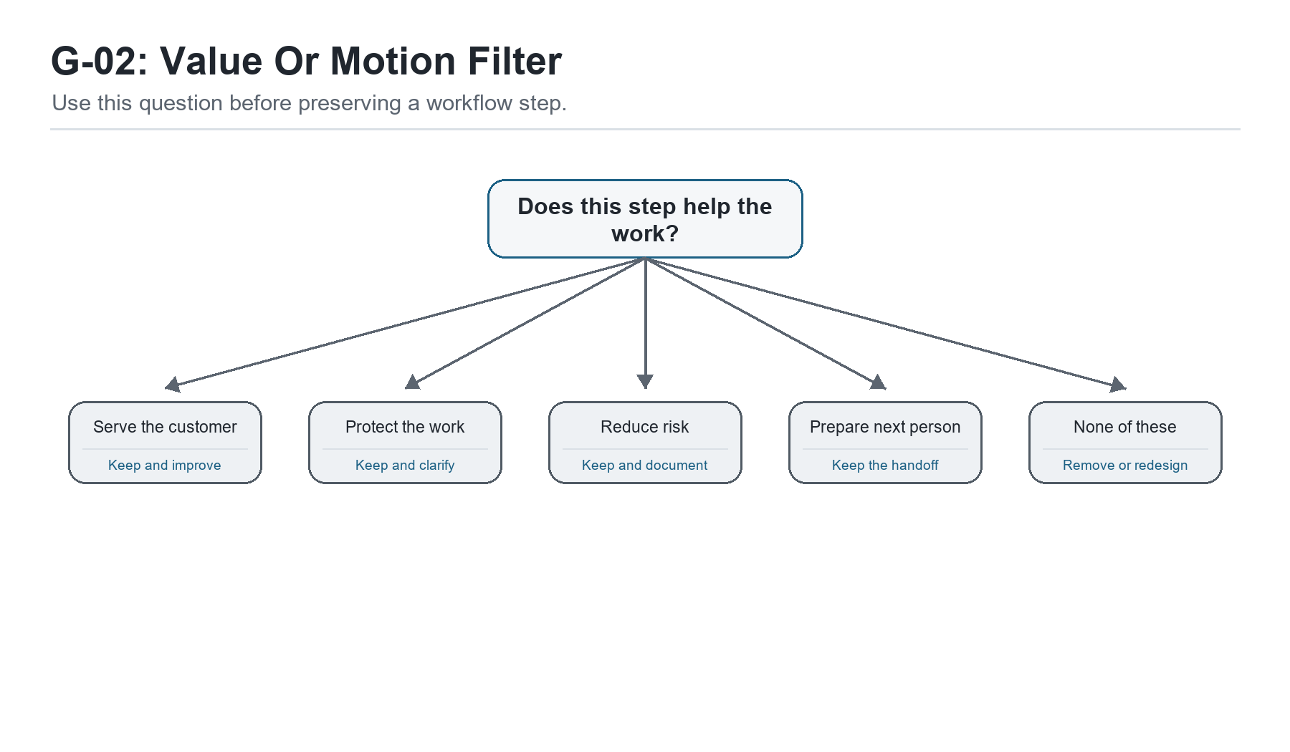
Figure G-02. Value Or Motion Filter. Use this question before preserving a workflow step.
Hey partner, once we can see the work, the next question is not, 'How do we make everyone move faster?' That question sounds efficient, but it can become unfair real quick. The better question is, 'What weight has the work been carrying that it does not need to carry anymore?'
That was Sam's next lesson. After we mapped one customer request in Chapter 1, he could finally see how the work traveled. He could see the text message, the note app, the proposal file, the email thread, the invoice tool, and all the places where his memory had been acting like a bridge. The map helped him understand the business he was actually running. But understanding the map was only the beginning.
Now we had to ask what should stay, what should change, what should be removed, and what should be strengthened. That is where streamlining begins.
A lot of people hear the word streamlining and think it means cutting corners. That is not what we are doing. We are not trying to make the work cheaper by making it careless. We are not trying to squeeze people harder so the spreadsheet looks better. We are trying to remove unnecessary burden so the business can serve better with less confusion.
There is a difference between disciplined work and heavy work. Disciplined work has a clear path. Heavy work makes good people carry unclear paths in their heads. Disciplined work protects the customer. Heavy work asks the customer to wait while the business figures itself out. Disciplined work can be repeated and improved. Heavy work has to be rescued over and over again.
Sam's business had plenty of heavy work. Not because he had designed it badly on purpose. It had simply grown in pieces. One tool had been added when leads got messy. One template had been created when proposals took too long. One spreadsheet had been started when follow-up slipped. One contractor had been brought in when delivery got tight. Each piece had a reason. Together, they had become a load.
That is how most small business systems happen. They are not built from a clean blueprint. They are patched together in motion by a founder trying to keep promises. I respect that. Sometimes patching keeps the doors open. But there comes a time when the patches need to become a system, or the founder becomes the permanent repair crew.
So I asked Sam to bring the current-state map back to the table. We looked at the customer request path again, but this time with a different question in mind: which steps actually create value, and which steps only create motion?
Motion is activity. Value is activity that helps the customer, protects the quality of the work, reduces risk, creates useful information, or prepares the next person to act. Motion can make a founder feel busy. Value makes the business stronger.
This distinction matters because small businesses often reward motion by accident. The owner is answering messages, updating notes, checking three tools, rewriting proposals, reminding himself to invoice, and following up late at night. From the outside, that looks like dedication. And it is dedication. But dedication should not be forced to compensate for a process that could be lighter.
Sam saw it when we went step by step. Replying to a referral was value. Capturing the lead in one reliable place was value. Rewriting the same proposal language every time was mostly motion. Searching email for the customer's original details was motion. Manually remembering the follow-up was risk wearing the clothes of effort. Creating the invoice two days late was not value; it was delayed cash flow.
None of those observations made Sam a bad operator. They gave him a better target. We were not attacking him. We were attacking unnecessary weight.
Uncle Robert's Note: do not confuse effort with design
A founder can work very hard inside a poorly designed workflow. The goal is not to question the founder's heart. The goal is to question whether the process is worthy of the effort being poured into it.

The first streamlining move is deconstruction. That is a fancy word for taking the workflow apart so we can see what each piece is doing. We are not destroying the process. We are laying it on the table. We want to see the trigger, the steps, the handoffs, the decisions, the tools, the waits, and the outputs.
When Sam deconstructed the proposal process, it looked simple at first. Customer asks for help. Sam sends proposal. Customer approves. Work begins. But when we slowed it down, the hidden steps appeared. Sam read old messages. He opened a previous proposal. He copied sections. He rewrote the scope. He checked pricing from memory. He searched for a similar project. He adjusted the timeline. He sent the proposal. Then he waited. Then he followed up if he remembered. Then he answered questions. Then he updated the scope again.
That was not one step. That was a cluster of steps pretending to be one step.
This is why founders sometimes underestimate their own workload. They name the big activity, but they do not count the smaller actions inside it. 'Send proposal' sounds like one task. In real life, it may contain research, judgment, copywriting, pricing, scheduling, risk management, customer communication, and follow-up. If that task is not structured, it will drain more attention than the owner expects every single time.
Once we saw the cluster, we could ask better questions. Which parts need Sam's judgment? Which parts could be standardized? Which parts should be reusable? Which parts should be checked before sending? Which parts should trigger the next action automatically or at least visibly?
That is streamlining. Not rushing. Not dumbing down. Clarifying where human judgment belongs and where repeatable structure should carry the load.
For Sam, the proposal needed three layers. First, a standard proposal shell with the sections that rarely changed. Second, a small menu of service blocks that could be selected and customized. Third, a review checklist before sending: scope clear, price clear, timeline clear, next step clear, invoice trigger clear. That small structure kept the proposal personal without forcing Sam to rebuild it from scratch every time.
Notice what we did not do. We did not remove Sam's voice. We did not make the proposal generic. We did not automate the relationship. We simply stopped making creativity do the job of structure.
That is one of the main lessons in this chapter: structure is not the enemy of creativity. Confusion is. When the basics are unclear, the founder spends creative energy recovering from preventable disorder. When the basics are clear, creativity can be used where it actually matters: understanding the customer, shaping the offer, solving the problem, and strengthening the relationship.
Let's Make This Practical: deconstruct one workflow
Pick one workflow from Chapter 1 and break it into smaller parts. Do not accept broad labels like "send proposal" or "onboard client" until you have named the real steps inside them.
What triggers the workflow?
What is the first visible action?
What information is needed before the next step can happen?
What steps require human judgment?
What steps are repeated almost the same way each time?
Where does the work wait?
Where does the customer wait?
What output should exist at the end?

After deconstruction comes evaluation. This is where we look at each step and ask whether it deserves to stay the way it is. I like to keep the questions simple because simple questions get used.
Does this step serve the customer? Does it protect quality? Does it reduce risk? Does it help the next person act? Does it create information we actually use? Does it support cash flow? Does it help the business learn?
If the answer is yes, the step may need to stay. It may still need to be improved, but it has a purpose. If the answer is no, we need to ask why it exists. Maybe it is a leftover from an older version of the business. Maybe it was added because one customer once caused a problem. Maybe a tool forced the step. Maybe nobody remembers. That happens more often than we like to admit.
Sam found one of those steps in his client onboarding process. After a proposal was accepted, he sent a long email asking the customer for several pieces of information. Then, after the customer replied, he copied parts of that response into his notes, parts into a project folder, and parts into the invoice system. He did this because that was how the process had grown. But when we asked what the step was for, the answer became clear: Sam needed consistent setup information in one place.
The long email was not the real requirement. The real requirement was clean intake. Once we knew that, we could improve the step. A simple setup form or structured setup note could capture the same information once and reduce copying. The customer would have a clearer experience. Sam would have fewer places to check. The work would become easier to hand off later.
That is how we remove weight. We do not remove the need. We remove the messy way the need is being met.
Another place to look is handoffs. Every handoff is a risk point. That does not mean handoffs are bad. Businesses need them. But when work moves from one person to another, from one tool to another, or from one phase to another, something can get lost. A good handoff says: here is what happened, here is what matters, here is what is next, here is who owns it, and here is where the information lives.
Sam had handoffs even when he was the only person involved. That may sound strange, but solo founders hand work off to their future selves all the time. A note written today becomes a handoff to tomorrow. A folder name becomes a handoff to next week. A follow-up reminder becomes a handoff to the version of you who will be busy when it fires. If those handoffs are sloppy, the solo founder still pays the cost.
That was a helpful realization for Sam. He had been thinking, 'I do not need a process because it is just me.' But the truth was, because it was just him, he needed the process even more. The process was not there to control a team. It was there to protect his attention.
Watch for This: solo founders still have handoffs
If you work alone, your handoffs are often between today-you and tomorrow-you. Treat those handoffs with respect.
Name files so future-you can find them.
Write the next action before stopping work.
Store customer information in the same place each time.
Use follow-up dates instead of memory.
Leave short notes that explain why a decision was made.

The next streamlining move is combination. Sometimes a workflow has too many small steps because nobody has asked whether two of them can become one. A customer gives information in one place, then the business asks for it again. A team member reviews a file, then another person checks the same thing. A lead gets captured in one spreadsheet, then copied into another. Each step may feel small, but small frictions compound.
For Sam, proposal acceptance and setup were separated by habit. The customer approved the proposal, then later received a setup email. That gap created delay. We asked whether the proposal could include a clear next step and a link or instruction for setup immediately after approval. It could. That one change reduced uncertainty for the customer and reduced follow-up work for Sam.
Another combination came from the proof loop. Sam used to finish a project, feel good about it, and move on to the next thing. Later, he might remember to ask for feedback. Sometimes he did. Sometimes he did not. We decided that project closeout should include three things in one short routine: confirm completion, ask for feedback, and record any proof or referral opportunity. That turned the end of delivery into the beginning of learning.
This is important because streamlining is not only about speed. It is also about making sure important lessons do not fall off the back of the truck. A business that does not capture feedback has to keep learning the same things informally. A business that does not capture testimonials has to keep proving itself from scratch. A business that does not record objections has to keep being surprised by the same hesitation.
So when we combine steps, we are not just trying to reduce clicks. We are trying to preserve meaning. We are asking: when this moment happens, what else should happen while the context is fresh?
Then comes elimination. This is the one people think of first, but it should not be the only move. Some steps simply need to go. A report nobody reads. A meeting with no decision. A duplicate approval. A tool update that does not feed any real process. A form field nobody uses. These things consume attention quietly.
I told Sam to be careful here. Do not remove a step just because it annoys you. Some annoying steps protect the business. But do not preserve a step just because it has been there a long time. Longevity is not proof of value. It may only be proof that nobody has questioned it yet.
One of Sam's old steps was maintaining a second project list because he once thought he might use it for reporting. He never did. The second list was always behind, which made him feel guilty and created uncertainty about which list was true. We removed it. One source of truth is better than two sources of anxiety.
That phrase made Sam laugh, but it stayed with him: one source of truth is better than two sources of anxiety.
Try This This Week: combine or remove one step
Choose one small workflow improvement that can be tested without rebuilding everything.
Combine proposal approval with the next setup instruction.
Replace a repeated email with a reusable template.
Remove one report, list, or tracker nobody actually uses.
Turn project closeout into feedback plus proof capture.
Choose one official source of truth for leads or projects.

Now we need to talk about automation again, because this is where a lot of founders get tempted. Once Sam saw the workflow, he wanted to know what tool could automate it. That is a fair question, but it was not the next question. The next question was whether the manual version was clean enough to automate.
Automation should carry a process that already makes sense. It should not be asked to decide what the process is. If the founder does not know the trigger, the input, the owner, the next step, and the desired output, automation has nothing stable to carry.
This is why I like to say: manual before magical. Run the process by hand until the pattern is clear. Then automate the part that repeats. That does not mean waiting forever. It means respecting the difference between discovery and scale. In discovery, we are still learning what should happen. In scale, we are trying to make the proven thing happen more reliably.
Sam's lead process was not ready for full automation yet, but parts of it were ready for structure. We could create a standard intake tracker. We could create a proposal template. We could create follow-up reminders. We could create a setup note. Those moves did not require a complex build. They created a stable path. Later, when the pattern was tested, automation could connect the intake form, follow-up reminders, setup packet, and proof capture.
That sequence protects the buyer too. If Sam later sells or teaches this system to someone else, he should not hand them a flashy automation that only works under perfect conditions. He should hand them a process with a manual fallback, clear ownership, and automation that has earned its place. That is the difference between a demo and a product.
Continuous improvement ties all of this together. We are not trying to create the final workflow in one pass. We are building a loop: plan, try, watch, adjust. Some people call that PDCA: Plan, Do, Check, Act. I like the plain language too. Decide what you are testing. Run it. Look at what happened. Update the system.
For Sam, the first test was simple. For one week, every new lead would go into one tracker by the end of the business day. Every proposal would use the new shell. Every accepted proposal would trigger the setup note. Every completed project would have a closeout note that captured feedback or proof. At the end of the week, he would review what worked and what still felt heavy.
That is how you keep improvement from becoming another overwhelming project. You make the test small enough to run and meaningful enough to teach you something.
A week later, Sam noticed three things. First, the lead tracker gave him relief because he no longer had to remember where every conversation lived. Second, the proposal shell saved time without making the proposal feel canned. Third, the setup note reduced customer questions. That was enough evidence to keep the changes and improve them.
He also noticed one problem: he still forgot to capture feedback after delivery. Good. That was not failure. That was information. The closeout step needed a stronger trigger. We tied it to the project completion message. When the project was marked complete, the closeout note had to happen before the job was considered fully done.
This is how systems mature. Not by pretending the first version is perfect. By learning from the first version and updating it.
Update the System: the simple improvement loop
Use this loop whenever a workflow feels heavy.
Plan: choose one improvement and define what should change.
Do: run the improved process in real work.
Check: review what became easier, what broke, and what still depends on memory.
Act: keep, revise, or remove the change. Then update the checklist or SOP.

Employee involvement matters here too, even if the team is small. If there are people doing the work, they should help improve the work. The person closest to the friction often knows something the owner cannot see. They know which field is confusing, which handoff is late, which customer question keeps repeating, which tool creates extra steps, and which workaround has quietly become the real process.
If the owner improves workflows without listening, the business may create beautiful processes that do not survive contact with reality. Servant leadership asks us to honor the people carrying the work by letting their experience inform the system.
That does not mean every suggestion becomes policy. Leadership still has to decide. But people are more likely to follow a process they helped make honest. And they are more likely to improve a process when they know the purpose is service, not surveillance.
In Sam's case, he had one contractor who helped with delivery. At first, Sam thought the contractor did not need to be part of the process conversation. Then he realized the contractor often waited on unclear setup details. That wait time affected delivery. So Sam asked a better question: what information do you need before you can do your part well?
The contractor's answer improved the setup note. It added two fields Sam had not thought to include. That small conversation saved future delay. It also reminded Sam that process is not just a founder exercise. It is how the business teaches everyone to serve better.
By now, the original workflow had changed shape. The lead had one source of truth. The proposal had a reusable structure. The acceptance step pointed directly to setup. The setup note gave the customer clarity. The closeout routine captured learning. The contractor had better information. The owner had less invisible load.
That is what removing weight looks like. It is not always dramatic. It may not look like a transformation from the outside. But inside the business, people can feel it. The work moves with less drag. The customer receives clearer communication. The founder has more attention left for judgment and growth.
And this is where I want to be very clear: streamlining is not a one-time cleanup. It is a leadership habit. Every time the business grows, the work will create new weight. That is normal. The goal is not to prevent all friction forever. The goal is to notice friction sooner, question it honestly, and update the system before confusion becomes culture.
We do things differently now because we know more now. That sentence belongs in every growing business. It gives the owner permission to mature without pretending the old way was shameful. The old way got Sam this far. The new way would help him go farther without carrying everything alone.
Chapter 2 working takeaway: simplification is not about doing less important work. It is about removing the weight that keeps important work from moving well.

Going Deeper: The Kinds of Weight a Workflow Carries
Once Sam understood value versus motion, we needed a better vocabulary for the weight inside the workflow. If all we say is, 'This feels messy,' we may be telling the truth, but we do not yet know what to fix. The work becomes easier when we can name the kind of waste we are seeing.
Some weight comes from waiting. The customer waits for the next step. The contractor waits for setup details. The invoice waits for Sam to circle back. Waiting may look harmless because nothing loud is happening, but waiting is one of the most expensive forms of friction. It slows revenue, weakens trust, and makes the owner feel like the business is always behind.
Some weight comes from searching. Sam searched old emails for customer details. He searched folders for the right proposal. He searched his notes to remember what was promised. Searching is a sign that the business has information but not order. The answer exists somewhere, but the system has not made it easy to retrieve.
Some weight comes from rework. Rework happens when the same work has to be corrected, repeated, rewritten, or re-entered because the first pass did not carry the information cleanly. In Sam's case, proposal language had to be rewritten too often. Setup details had to be clarified after the fact. Follow-up had to be reconstructed from memory. Rework is discouraging because it makes a hardworking person feel like the day is full but not productive.
Some weight comes from overprocessing. That means doing more than the situation requires. A report nobody reads. A five-step approval for a low-risk decision. A long email where a short setup form would do. A beautiful dashboard that does not change any decision. Overprocessing can hide inside professionalism. We think we are being thorough, but sometimes we are just making the work heavier than it needs to be.
Some weight comes from unclear ownership. This one is dangerous because everyone can be working and still no one knows who is responsible for the outcome. Sam saw this with his contractor. The contractor was responsible for part of delivery, but Sam had not clearly defined what information had to be ready before that work began. When the setup details were incomplete, the contractor waited, Sam got interrupted, and the customer felt delay.
Some weight comes from tool friction. A tool can be powerful and still be wrong for the current stage. A tool can have many features and still not solve the founder's actual problem. A tool can make a business look more organized while quietly asking the owner to maintain another system. The question is not, 'Is this tool good?' The question is, 'Is this tool serving this workflow at this stage of the business?'
Naming the weight helps us choose the right response. Waiting may need a trigger. Searching may need a source of truth. Rework may need a template or checklist. Overprocessing may need deletion. Unclear ownership may need a role decision. Tool friction may need simplification or consolidation.
This is why operational excellence is not one move. It is discernment. Different problems need different kinds of correction.
Operator Checkpoint: name the workflow weight
Before changing a workflow, name the kind of burden you are trying to remove.
Waiting: work sits too long before the next action.
Searching: information exists but is hard to find.
Rework: the same work must be corrected, repeated, or re-entered.
Overprocessing: the process is more complicated than the risk requires.
Unclear ownership: people touch the work, but no one owns the outcome.
Tool friction: the tool adds maintenance without enough value.

We also needed to decide when standardization would help. Some founders resist standardization because they hear it as sameness. They think a standard process means every customer gets treated like a number. I understand that fear, especially in a service business where relationship matters. But good standardization does not erase care. It protects the parts of care that should not depend on mood, memory, or available energy.
A standard does not have to be cold. A standard can say: every customer gets a clear next step. Every proposal includes scope, timeline, price, and follow-up. Every project starts with the right setup details. Every completed project gets a closeout. Every complaint gets recorded and reviewed. Those standards do not make the business less human. They help the business keep its promises when life gets busy.
Sam began to see this when we talked about his customer communication. He cared about his customers, but his communication rhythm changed depending on workload. When he was fresh, he was proactive. When he was overloaded, customers waited longer. That is normal human behavior, but it is not a reliable customer experience. A simple communication standard helped: after proposal acceptance, the customer gets a setup note within one business day. During delivery, the customer gets an update at the agreed checkpoint. At closeout, the customer gets a completion note and feedback request.
That rhythm did not remove Sam's personality. It gave his personality a reliable vehicle.
Standards also make delegation possible. If the process only exists in Sam's head, nobody else can help without becoming another interruption. But if the standard is visible, someone else can take a step, check their work, and know what good looks like. This is how a founder begins to move from doing everything to teaching the business how things are done.
The phrase 'what good looks like' is important. A process is not complete just because the steps are listed. People need to know the standard of a good output. What makes a good lead record? What makes a good proposal? What makes a good setup note? What makes a good closeout? Without that, a checklist may produce activity without quality.
For Sam, we defined a good proposal as one that made five things clear: the customer's problem, the promised outcome, the scope of work, the price and payment terms, and the next step. If those five things were clear, the proposal could still sound personal. If those five things were missing, a beautifully written proposal could still create confusion.
That gave Sam a standard he could use and later teach. He did not have to ask, 'Do I like this proposal?' He could ask, 'Does this proposal make the five things clear?' That is a better question. It moves the work from preference to clarity.
What the Founder Notices: standards protect care
Sam learns that structure is not the enemy of creativity. A good standard protects the promises that should not depend on how busy the founder feels.
A standard lead record protects follow-up.
A standard proposal protects clarity.
A standard setup note protects customer confidence.
A standard closeout protects learning and proof.
A standard review protects quality before delivery.

There is also an emotional side to streamlining that we should not ignore. When a founder has built the business through effort, simplifying the work can feel like admitting the old way was wrong. I do not see it that way. The old way was often the bridge that got the business here. We can honor the bridge without deciding to live on it forever.
I told Sam, 'The process you have now helped you survive the first stage. We are not here to insult it. We are here to build the next stage.' That matters. If the founder feels accused, he may defend the current process even while it hurts him. If he feels respected, he can tell the truth about what needs to change.
This is part of servant leadership. We do not use process improvement as a weapon. We use it as a way to serve the people doing the work and the people receiving the work. The question is not, 'Who messed this up?' The question is, 'What is the system asking people to carry, and what can we take off their shoulders?'
That posture changes the conversation. The contractor can say, 'I need clearer setup details' without sounding like he is blaming Sam. Sam can say, 'I need the closeout step to remind me' without pretending he has unlimited memory. The business can admit that a tool is not working without turning the purchase into a personal failure. Everybody gets to learn.
This is why I want continuous improvement to feel ordinary. If improvement only happens after something breaks badly, the team will associate improvement with crisis. If improvement happens every week in small ways, the team learns that updating the system is part of doing honest work.
Sam started a weekly improvement review. It was short. Fifteen to twenty minutes. He looked at the customer request path and asked three questions: What felt heavy this week? What created clarity? What should we update before next week? That was enough to keep the process alive.
The review did not need to become a meeting empire. It needed to create a rhythm. A business with a rhythm can improve without drama. It can notice small issues before they become expensive. It can adjust tools before they become clutter. It can update standards before people stop trusting them.
As Sam practiced this, he began to change the way he talked about operations. He stopped saying, 'I am behind on everything,' and started saying, 'This process has too many memory points.' That is a powerful shift. One sentence traps the founder in guilt. The other points to a fix.
Language matters. When we can name the operational issue clearly, we can respond to it with less shame and more precision.
Update the System: weekly improvement review
Keep the review short enough to sustain. The goal is not a long meeting; the goal is a living process.
What felt heavy this week?
Where did the customer wait or wonder?
Where did the founder or team rely on memory?
What step saved time or created clarity?
What should be updated before next week?

By the end of this second stage, Sam's business had not become perfect. That is not how real improvement works. But the work had become lighter in specific ways. Leads had one table. Proposals had a structure. Setup details had a home. Closeout had a trigger. Feedback had a place to go. The contractor had clearer information. Sam had fewer things depending only on his memory.
Those are operational wins. They may not sound as exciting as a new launch or a big marketing campaign, but they create the foundation those things need. Growth without workflow clarity creates more pressure. Growth with workflow clarity creates more capacity.
This is why Chapter 2 comes before the productivity chapter. We should not ask people and tools to produce more until we have removed some of the weight from the work. Otherwise, productivity becomes a polite word for overload.
When the workflow is lighter, people can bring more attention to the part of the work that actually needs them. The founder can think. The contractor can deliver. The customer can trust the next step. The business can learn from what happened instead of simply rushing into the next emergency.
That is the gift of streamlining when it is done with the right spirit. It does not make the business less personal. It makes the personal care more reliable.
And partner, that is what we are after. Not a business that looks organized while wearing everybody out. A business that is organized enough to serve well, grow honestly, and keep updating as the truth gets clearer.

Chapter 3: People, Time, and Tools Are Not Infinite
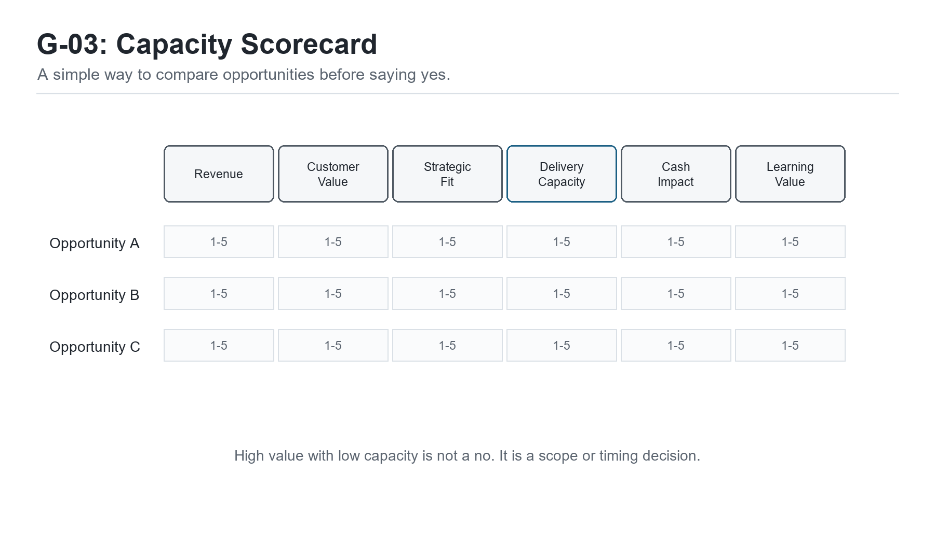
Figure G-03. Capacity Scorecard. A simple way to compare opportunities before saying yes.
Hey partner, after Sam mapped the work and started removing some of the weight from it, he ran into the next truth every growing founder meets sooner or later: people, time, and tools are not infinite.
That sounds obvious when we say it out loud. Everybody knows there are only so many hours in a day. Everybody knows a small business does not have unlimited money, staff, energy, or attention. But many founders still plan like those limits are negotiable. They say yes to one more client, one more project, one more tool, one more partnership, one more improvement idea, one more content plan, one more late-night catch-up session. Then they wonder why the business feels crowded even when the opportunity is good.
Sam was right there. Chapter 1 helped him see the business. Chapter 2 helped him lighten the workflow. But now he was excited. That can be dangerous in a good way. Once a founder starts seeing what can be improved, the mind opens up. Suddenly everything looks fixable. The lead tracker needs cleanup. The proposal can be better. The website needs clearer copy. The follow-up can be stronger. The contractor needs a handoff. The bookkeeping should be reviewed. The content calendar could finally get moving. And because all of those things are real, the founder is tempted to treat all of them as urgent.
I told Sam, 'Hope is not a calendar.' He laughed, but he knew I was telling the truth.
Hope matters. Vision matters. Energy matters. But hope cannot tell you whether you have capacity this week. Vision cannot decide who owns the next step. Energy cannot make a person be in three places at once. A business grows stronger when it learns to respect limits without being ruled by fear of them.
Resource management is not just a finance topic. It is a leadership practice. It asks: what do we have, what are we asking it to carry, and what happens if we keep pretending the gap does not exist?
For Sam, the scarcest resource was not money at first. It was attention. His attention was holding the leads, the proposals, the customer details, the follow-ups, the delivery quality, the contractor questions, and the future plans. When one person's attention becomes the main operating system, the business may still function, but it will not feel peaceful. It will feel like the founder is always one interruption away from dropping something important.
So before we talked about hiring, tools, or automation, we talked about capacity. What can the business actually carry right now? What work must happen every week? What work creates revenue? What work protects customer trust? What work is important but not urgent? What work is just noise dressed up as progress?
That last one matters. Founders love progress. I do too. But not every activity that feels productive is actually moving the business. Sometimes the founder is organizing the tool stack because follow-up feels uncomfortable. Sometimes he is redesigning a document because making an offer feels risky. Sometimes he is researching software because the real issue is role clarity. Capacity planning helps us tell the difference.
Uncle Robert's Note: every yes spends something
Every yes spends time, attention, money, trust, or energy. A founder does not become disciplined by saying no to everything. He becomes disciplined by knowing what each yes will cost.
What will this commitment require this week?
Who will own it?
What current work will slow down because of it?
What happens if we wait?
Does this yes serve the current mission or only the current mood?

The first practical move was to list Sam's active commitments. Not the dream list. The real list. Current clients. Open proposals. Follow-ups due. Administrative tasks. Content ideas. Tool cleanup. Contractor coordination. Invoices. Personal obligations. The work of a small business does not live only in the business calendar. It lives in the whole life of the founder, and if we ignore that, we create plans that look good on paper and fail in the real week.
When Sam put the list on the table, he saw why he felt behind. He was not behind because he lacked character. He was behind because the list was bigger than the available capacity. That distinction matters. Shame says, 'I should be better.' Clarity says, 'This load needs a decision.'
Once the load was visible, we could prioritize. Prioritization is not about choosing what matters and pretending everything else is worthless. It is about choosing sequence. What must happen first because it protects cash, trust, delivery, or learning? What can wait without harming the business? What should be delegated, simplified, paused, or removed?
I like simple scoring when a founder has too many possible priorities. We can score each item against a few questions: does it protect revenue? Does it improve customer experience? Does it reduce operational burden? Does it align with the direction of the business? Can we actually complete it with the capacity we have? What is the risk if we ignore it?
This does not turn wisdom into math. I do not want a founder hiding behind a spreadsheet when judgment is needed. But a scoring method slows down impulsive yeses. It helps the founder explain decisions to himself and others. It also makes trade-offs visible.
Sam's first scoring pass surprised him. He thought the website copy was the top priority because it had been bothering him. But the scoring showed that overdue follow-ups and proposal standardization had a more immediate effect on revenue and trust. The website mattered, but it was not first. That gave Sam permission to stop carrying it as an emotional emergency.
That is one of the gifts of prioritization. It does not only tell you what to do. It tells you what you can stop worrying about for now.
Opportunity cost is the grown-up language for that. Every choice has a cost because choosing one thing means not choosing something else right now. If Sam spends the afternoon redesigning the website, he is not following up with three warm leads. If he spends the week testing a new tool, he is not improving the process that already has customers waiting. If he says yes to a low-fit project, he may lose the time needed to serve a better-fit customer well.
Small business owners feel opportunity cost in their bodies before they name it. It feels like being stretched, scattered, and always late to your own priorities. Naming it helps. It reminds the founder that time is not just passing. It is being invested somewhere.
Let's Make This Practical: priority scorecard
Use a simple 1-5 score for each possible priority. The purpose is not perfection; the purpose is better judgment.
Revenue protection or growth
Customer trust or experience
Operational burden reduction
Strategic fit with the current mission
Feasibility with current capacity
Risk if delayed

After prioritization, we looked at role clarity. Sam was still small, so he did not have a big team. He had himself, one contractor, a few outside services, and the occasional help of people who cared about the business. That is how many early-stage service businesses work. The org chart is not complicated, but the responsibilities can still be unclear.
A founder might say, 'It is just me,' but even then there are roles. Lead responder. Proposal writer. Project manager. Service provider. Quality reviewer. Invoice sender. Follow-up owner. Tool administrator. Content creator. Strategist. Customer service. Those roles may all sit inside one person for a while, but they are still different roles. If we do not name them, we cannot decide which ones should be protected, delegated, automated, or scheduled.
I asked Sam to write down every role he was playing in the customer request path. The list was longer than he expected. Then I asked which roles required his judgment and which roles only required consistency. That question changed the conversation.
Some tasks needed Sam. Understanding the customer's real problem needed Sam. Shaping the offer needed Sam. Reviewing quality before final delivery needed Sam, at least for now. But copying information from one place to another did not need Sam's highest attention. Sending a setup reminder did not need deep strategic thought. Checking whether a follow-up date existed did not require the founder's unique gift. Those tasks needed a system.
This is how delegation begins before hiring. Delegation is not only handing work to another person. It is separating the work into parts so the founder can see what should eventually move off his plate. A checklist can carry one part. A template can carry another. A contractor can carry another. Automation may carry another later. But nothing can move cleanly until the roles are named.
Flexible is not the same as unclear. In a small business, people may need to help in multiple places. That is fine. But flexibility should happen inside clarity. The team should know who owns the outcome, who contributes, who approves, and where the work lives. Otherwise flexibility becomes a polite word for confusion.
Sam's contractor gave us a good example. The contractor helped with delivery, but Sam had never clearly defined what a ready-to-start project looked like. So the contractor sometimes received incomplete information and had to ask questions. That was not the contractor being difficult. That was the process failing to define readiness.
We fixed it with a ready-to-start checklist. Customer contact confirmed. Scope confirmed. Files or access received. Timeline confirmed. Payment or invoice status clear. Special notes captured. Once those items were present, the contractor could begin without waiting on Sam's memory. That one checklist improved capacity because it reduced interruption.
Operator Checkpoint: name the hidden roles
Even if one person performs several roles, name the roles separately. This makes delegation and automation possible later.
Who receives the lead?
Who qualifies the problem?
Who writes or sends the proposal?
Who owns project setup?
Who performs the work?
Who checks quality?
Who sends the invoice?
Who follows up and captures proof?

Now we can talk about tools with more honesty. Tools are resources too. They spend money, time, attention, and trust. A tool can help a business scale, but a tool can also become a needy employee that never stops asking to be managed. The question is not whether a tool is impressive. The question is whether the tool fits the job, the stage, and the people using it.
Sam's tool stack had grown out of moments of pain. That is common. A founder feels lead pain and buys a CRM. Feels scheduling pain and buys a scheduler. Feels project pain and buys a project board. Feels content pain and buys a planning app. Each tool promises relief, and some may deliver it. But if the tools are adopted without a clear operating backbone, the business may end up with more places to check and fewer decisions actually getting easier.
We reviewed Sam's tools by asking four questions. What job is this tool supposed to do? Who maintains it? What breaks if we stop using it? Is there a simpler or lower-cost path that works for now?
One tool had no clear job anymore. It had been useful during a past project, but now it mostly held stale information. Another tool was useful but underused because Sam had not built it into the weekly rhythm. A third tool was doing a job that a simple spreadsheet could handle at the current stage. None of that meant Sam was foolish. It meant the business had grown by trying things. Now it needed to update the tool stack in light of the truth.
This is one of the standards I want founders to carry: tools must earn their place. A tool earns its place when it removes recurring labor, reduces mistakes, improves decisions, protects revenue, or helps serve customers better. If it mostly creates another dashboard to maintain, it may not be automation. It may just be rent.
For Sam, the immediate decision was not to buy more tools. It was to choose an operating backbone. Where would leads live? Where would project notes live? Where would follow-up dates live? Where would invoices live? Where would proof live? The answer did not need to be fancy. It needed to be consistent.
Consistency creates capacity. If Sam always knows where a lead lives, he spends less attention searching. If the contractor always knows where setup details live, delivery starts faster. If invoices always follow a clear trigger, cash flow improves. If feedback always has a place, the business learns faster.
The tool is not the system. The system is the pattern of work the tool supports.
Watch for This: tool sprawl pretending to be progress
A larger tool stack does not automatically mean a stronger business. Review each tool by job, burden, and value.
What job does this tool perform?
Who owns and maintains it?
What decision does it improve?
What recurring labor does it remove?
What simpler path could work at the current stage?
Does it connect to the operating backbone or create another island?

Once roles and tools were clearer, we could build a capacity picture. Capacity planning sounds corporate, but it is really just asking whether the workload and the available resources match. How much work is coming in? How much time does it take? Who can do it? What skills are required? What deadlines are real? Where is the bottleneck?
Sam had been planning by feeling. If he felt energetic, he assumed he could take on more. If the calendar had white space, he assumed capacity existed. But white space on a calendar does not always mean capacity. A founder may have empty hours and still lack the mental room to do deep work. Or the calendar may show a meeting-free morning, but the business may still need follow-up, invoicing, customer communication, and review.
So we created a simple weekly capacity view. Not a complex forecast. Just a practical picture: current client work, sales follow-up, admin/finance, delivery review, content or marketing, improvement work, and personal constraints. We gave each bucket an estimated time requirement. Then we compared that to the real week.
Sam discovered that his planned work exceeded his available capacity by almost a full day. That explained the constant catch-up. He had been trying to fit six days of work into five days and blaming himself for not being more disciplined.
Sometimes the most compassionate thing a business can do is count honestly.
Once the capacity gap was visible, Sam had choices. He could delay a non-urgent improvement. He could simplify a deliverable. He could ask the contractor to take a clearer piece of work. He could block one finance/admin hour so invoices stopped slipping. He could stop pretending that content planning would happen magically after everything else was done.
Capacity planning does not remove hard choices. It reveals them early enough to make better ones.
It also helps protect quality. When the business is overloaded, quality often becomes dependent on heroic review at the end. That is risky. A better system makes sure quality is built into the process: clear setup, defined scope, readiness checklist, review point, customer confirmation, and closeout. Capacity and quality belong together because overloaded people miss things.
This is where training and development enter the picture. If a founder wants to delegate, people need the knowledge, tools, and standards to do the work well. Throwing work at someone without teaching the system is not delegation. It is passing confusion downstream.
Sam's contractor did not need a lecture. He needed a clear ready-to-start checklist, examples of good work, access to the right files, and a defined place to ask questions. That is training in practical form. Teach the standard. Show the example. Give the tool. Clarify the question path. Review the first few attempts. Then improve the process.
Try This This Week: build a weekly capacity view
Keep it simple. Estimate the real work before adding new commitments.
Current client delivery hours
Sales and follow-up hours
Admin, finance, and invoicing hours
Quality review hours
Marketing or content hours
Improvement/system-building hours
Personal or non-business constraints that affect the real week

Now let us talk about performance measurement. This is another place where founders can accidentally make life heavier. Once they decide to be more disciplined, they may want to track everything. Leads, calls, clicks, hours, tasks, revenue, impressions, conversion rates, response times, customer satisfaction, tool usage, and every other number a platform can produce. That may feel responsible, but too much measurement can become another form of clutter.
A useful metric helps the business see, decide, or improve. If it does not do one of those three things, it should be questioned. We are not building dashboards to feel mature. We are building feedback loops so the business can learn.
For Sam, we chose a small set of metrics tied to the current stage. New leads. Follow-ups due. Proposals sent. Accepted proposals. Invoices sent. Invoices paid. Delivery status. Customer feedback captured. Those measures told us whether the business was creating opportunity, responding to it, converting it, delivering on it, collecting from it, and learning from it.
That is enough for the stage Sam was in. Later, as the business grows, he can add more. But the discipline is not in having more numbers. The discipline is in reviewing the numbers that matter and acting on what they reveal.
Feedback loops make those numbers human. If a metric shows proposals are delayed, the answer is not automatically, 'Sam needs to work faster.' The answer may be that the proposal template is weak, intake is incomplete, pricing is unclear, or too many low-fit leads are entering the pipeline. The number points to a conversation. It does not replace judgment.
The same is true with people. Accountability should not be a surprise attack. If expectations are clear, metrics are visible, feedback is regular, and support is real, accountability becomes part of the operating rhythm. People know what matters and where they stand. That is very different from waiting until frustration builds and then calling it leadership.
Sam started a Friday review. Not long. Thirty minutes. He looked at the week through a few questions: What came in? What moved forward? What got stuck? What money is waiting? What customer needs a next step? What process needs an update? That review became one of the first real management habits in his business.
This is how a founder begins to lead the business instead of simply react to it.
Update the System: Friday feedback loop
Use metrics to learn, not to perform maturity. Review the few numbers that show whether the business is moving.
New leads received
Follow-ups due or overdue
Proposals sent and accepted
Invoices sent and paid
Delivery status and blockers
Customer feedback or proof captured
One process update needed before next week

By the end of this stage, Sam had not gained more hours in the day. He had gained a clearer relationship with the hours he already had. That is a major shift.
He could see which work belonged first. He could name the hidden roles inside his own job. He could review tools by value instead of hope. He could estimate capacity before saying yes. He could measure a few things that actually helped him decide. He could ask for help without handing someone a pile of confusion.
That is what better resource management does. It does not make the founder limitless. It makes the founder honest. And honesty creates better decisions.
The business still had constraints. It always will. But constraints are not enemies when they are visible. They are design requirements. They tell us how to build the next version of the system so it can carry the work with less strain.
Sam was beginning to understand that growth is not only about getting more. More leads, more customers, more revenue, more tools, more activity. Growth also requires better use of what is already there. Better use of attention. Better use of time. Better use of people. Better use of tools. Better use of the truth.
Chapter 3 working takeaway: capacity is a truth-telling tool. Once the business sees what people, time, and tools can actually carry, it can choose better.

Going Deeper: Resource Allocation Is a Teaching Tool
Once Sam could see his commitments and capacity, we had to talk about resource allocation. That phrase sounds like something from a management textbook, but in a small business it is very personal. It means deciding where the best time, attention, money, and energy should go next.
A founder can waste resources by spending too much money, but he can also waste resources by spending his best attention on low-value work. Sam had been giving prime mental energy to coordination tasks that could be simplified. Then, when it was time to think strategically, he was tired. That is backwards. The business needed his best judgment on offers, customers, quality, and direction. It did not need his best judgment spent searching for a missing setup detail.
We made a simple distinction between owner work, operator work, and system work. Owner work required Sam's judgment, relationships, decision-making, or authority. Operator work needed competent execution but not necessarily Sam. System work could be carried by a checklist, template, tracker, automation, or repeatable standard. This distinction helped him stop treating every task as if it deserved the same kind of attention.
For example, deciding whether a prospect was a good fit was owner work. Sending the same setup instructions after a proposal was accepted was system work. Completing a defined delivery task could become operator work once the standard was clear. Reviewing whether the offer still matched the market was owner work. Copying information from an email into the project folder was not.
That gave Sam a way to allocate resources by the nature of the work. Owner work should be protected. Operator work should be delegated when possible. System work should be standardized and eventually automated if the volume justifies it.
This is how a founder starts to get out of the trap of being both the visionary and the bottleneck. Not by disappearing from the business, but by putting his attention where it does the most good.
Operator Checkpoint: owner, operator, or system?
Classify recurring tasks before deciding what to delegate, document, or automate.
Owner work: requires judgment, authority, relationship, or strategic direction.
Operator work: requires capable execution once the standard is clear.
System work: should be carried by a checklist, template, tracker, or automation.
If everything is owner work, the business has not yet separated judgment from repetition.

Then we talked about skills. Capacity is not only about hours. It is also about capability. A person may have time available and still not be ready to own a task. Another person may have the skill but not the context. A tool may have the feature but not the setup. A founder may have the desire to delegate but not the documentation needed to make delegation fair.
This is where training becomes part of operations. Training does not have to mean a formal course. It may be a short walkthrough, a recorded example, a checklist, a sample deliverable, a review call, or a clear definition of what good looks like. The point is to transfer understanding, not just assign responsibility.
Sam wanted his contractor to handle more delivery coordination. That made sense, but only after we gave the contractor the right support. We wrote the ready-to-start checklist. We defined the folder structure. We created a sample status update. We agreed on when the contractor should ask a question and when he should proceed. That was training. Practical, specific, and tied to the actual work.
Delegation without training often creates more interruptions. The founder hands something off, the other person gets stuck, the work comes back with questions, and the founder thinks, 'It would have been faster to do it myself.' Sometimes that is true in the moment. But if it is always true, the business never grows past the founder's personal bandwidth.
The goal is not to make the first delegated attempt faster than doing it yourself. The goal is to make the third, fourth, and fifth attempt no longer depend on you. That requires patience. It also requires standards. A patient teacher does not just say, 'Figure it out.' He says, 'Let me show you how this works so you can own this process going forward.'
That line matters because it fits the whole spirit of this book. We are not building systems to make people replaceable. We are building systems to make people more capable.
Uncle Robert's Note: delegation is teaching
If the person receiving the work does not have the standard, the context, and the success criteria, the founder has not delegated. He has only relocated confusion.
Show the outcome.
Explain why it matters.
Provide the checklist or template.
Review early attempts.
Update the process when the handoff reveals missing context.

A week later, Sam brought his first capacity review. This was a different kind of map from the workflow maps in the first two chapters. This map showed the week itself. It had current client work, open sales conversations, follow-up tasks, admin and finance, contractor coordination, content planning, and one system improvement task.
At first glance, it still looked like too much. But now the overload had shape. We could see which work protected revenue, which work protected delivery, which work protected future growth, and which work was optional this week. That changed the conversation from, 'I am overwhelmed,' to, 'This week needs a trade-off.'
Sam had three possible improvement projects: clean up the website copy, finish the lead tracker, and organize old project files. All three were useful. But only one directly supported active revenue and follow-up this week. The lead tracker won. Website copy moved to next week. Old project files moved to a later cleanup block. Nothing was forgotten. It was sequenced.
That is a skill founders need to learn. Parking a task is not the same as ignoring it. A parked task has a place to wait. An ignored task floats around the founder's head and steals attention every time it passes by. A simple backlog, parking lot, or scheduled-change queue can be an act of mercy to the mind.
We also looked at Sam's energy patterns. He did his best thinking in the morning, but he had been using mornings to clear small messages because those messages made him anxious. Then he tried to do proposal work late in the day when he was tired. That was a resource allocation problem. The best attention was going to the loudest work, not the most important work.
So we redesigned the week gently. Morning blocks went to owner work: proposals, offer decisions, quality review, and important customer conversations. Lower-energy blocks went to admin, tool cleanup, and routine updates. Follow-ups were scheduled rather than left to emotional pressure. Finance got a fixed review window. The contractor got a clearer handoff time.
This did not make Sam's week easy. It made the week more honest. And honest weeks are easier to improve than imaginary ones.
What the Founder Notices: overload gets lighter when it has shape
Sam learns that overwhelm is often unsequenced work. Once the work is sorted by importance, timing, and owner, the founder can make decisions instead of carrying fog.
Park useful work that is not for this week.
Protect high-energy time for owner work.
Schedule follow-up instead of trusting pressure.
Give admin and finance a fixed home.
Review capacity before accepting new commitments.

We should also talk about accountability, because this word can get misused. In unhealthy systems, accountability becomes the thing leaders talk about when they are frustrated. Somebody missed something, and now accountability appears like a hammer. That is not the kind of accountability I want Sam to build.
Healthy accountability starts before the mistake. It begins with clear expectations, visible work, defined owners, reasonable capacity, and timely feedback. If those pieces are missing, accountability becomes unfair. You cannot hold someone properly accountable for a standard they never received, a deadline that was never realistic, or a process that kept changing without being updated.
For Sam, accountability started with himself. He had to stop making promises to the business that the week could not keep. He had to stop using memory as a management system. He had to stop treating unclear handoffs as personal inconvenience instead of process design work. That kind of self-accountability is not shame. It is leadership.
Then accountability extended to the contractor. The contractor agreed to review the ready-to-start checklist before beginning delivery. If something was missing, he would flag it in the agreed place. If everything was present, he would proceed without waiting on Sam. That gave the contractor responsibility and gave Sam relief. Both mattered.
The same principle applies to metrics. A number should not be used to embarrass people. It should help the business see whether the system is working. If follow-ups are overdue, we ask why. Is the owner overloaded? Is the reminder missing? Is the lead quality poor? Is the next step unclear? The number starts the investigation. It does not finish it.
Feedback should be regular enough that people are not surprised by reality. Sam's Friday review helped him see work before it became a crisis. A short contractor check-in helped delivery issues surface earlier. A simple customer feedback question helped the business learn from finished work. None of that required a corporate performance system. It required rhythm.
Rhythm is one of the most underrated resources in a small business. A rhythm tells the work when it will be seen. Monday pipeline. Midweek delivery check. Friday finance and feedback. Monthly tool review. Quarterly SOP review. When the rhythm is real, the founder does not have to hold everything in active memory every day.
This is where operations begin to support peace. Not because there is no work, but because the work has a place to go.
Update the System: accountability before frustration
Build accountability into the process before people are tired and disappointed.
Define the standard before judging the result.
Assign one owner for each outcome.
Check capacity before setting the deadline.
Review progress while there is still time to adjust.
Use misses to improve the system, not just blame the person closest to the miss.

As Sam practiced these rhythms, his relationship with the business began to change. The business still needed him, but it did not need to live entirely inside him. That is the point. A healthy small business does not remove the founder's influence. It gives that influence a structure that can be shared.
He started to notice when a task was asking for the wrong kind of attention. He started asking, 'Is this owner work, operator work, or system work?' He started parking good ideas instead of letting them interrupt active priorities. He started reviewing tools by usefulness instead of guilt. He started seeing capacity before commitment.
Those are quiet changes, but they are powerful. They mark the beginning of management. Not management as control for its own sake. Management as stewardship. Management as teaching the business how to carry what matters.
This is also where creativity gets protected again. Remember, Sam was learning that structure is not the enemy of creativity. Chapter 3 proves that in another way. When people, time, and tools are respected, creative energy has room to work. When everything is overcommitted, creativity gets used to escape consequences instead of create value.
A founder with protected attention can think better. A team with clear roles can contribute better. A tool with a defined job can serve better. A metric with a purpose can teach better. Capacity is not a limitation to resent. It is one of the truths that helps us build wisely.

Chapter 4: Profit Is a Practice
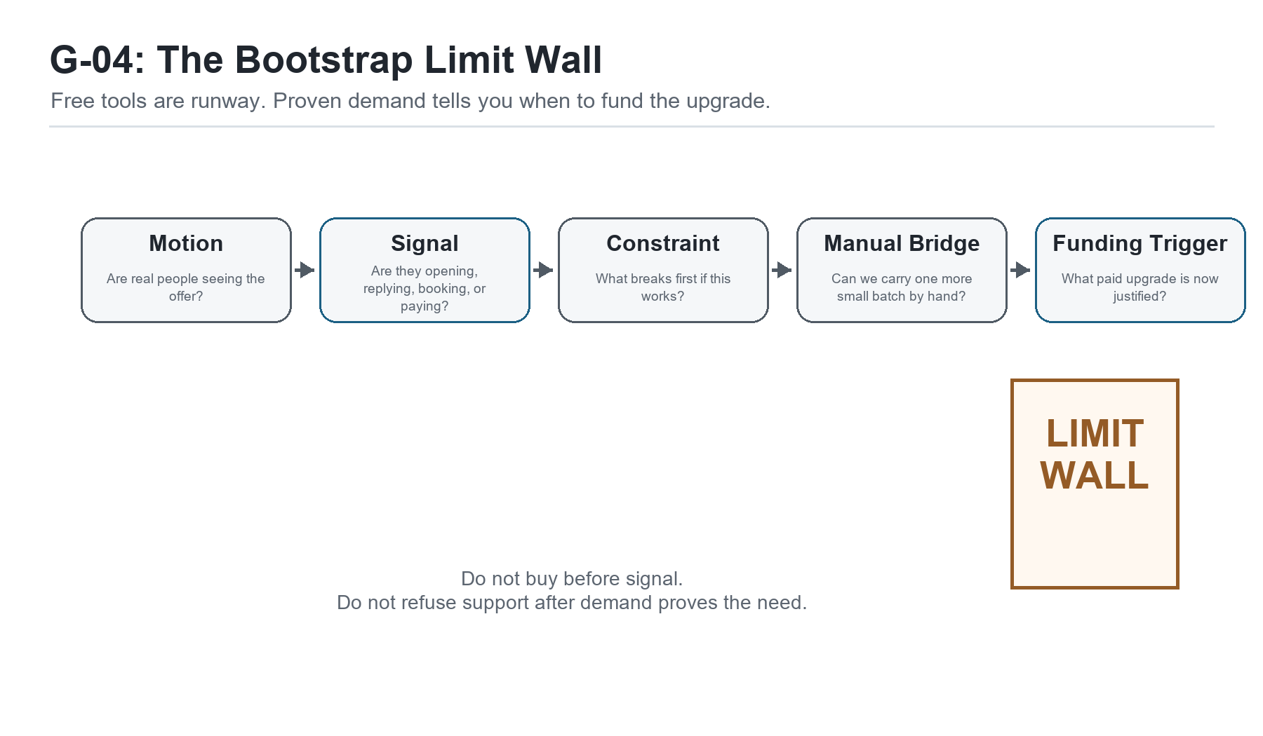
Figure G-04. The Bootstrap Limit Wall. Free tools are runway. Proven demand tells you when to fund the upgrade.
Hey partner, there is a moment in a small business when the founder realizes
busy and funded are not the same thing.
Sam reached that moment after he had done some good work. That is important to
say first. He had not failed. He had mapped the business. He had removed some
weight from the work. He had started seeing his own capacity more clearly. He
was following up better. He was carrying less in his head. The business was not
perfect, but it was more visible than it had been.
And still, cash felt tight.
That can be discouraging for a founder because effort has a way of asking for
payment before the market does. Sam had spent long days doing the right things:
serving customers, cleaning up proposals, answering messages, improving the
workflow, learning the tools, and trying to keep the business moving. But when
he looked at the account, the numbers did not feel like the work.
He said, "I am busier than ever, but I do not feel safer."
That sentence matters. A lot of founders live there. The calendar is full, the
mind is full, the inbox is full, and the bank account is still not giving them
room to breathe.
So I told Sam something I want you to carry with you:
Profit is not just a number at the bottom of a report. In a small business,
profit is breathing room.
Profit is what lets the founder sleep. Profit is what lets the business keep a
promise without panic. Profit is what lets you pay for the tool after the free
version stops being enough. Profit is what lets you choose the right help
instead of taking whatever help is cheapest in the moment. Profit is not greed.
Profit is oxygen.
That does not mean every decision should be reduced to money. A business has
people, purpose, quality, trust, and craft inside it. But if the business never
creates margin, the founder eventually becomes the margin. Their evenings
become the margin. Their health becomes the margin. Their family time becomes
the margin. Their patience becomes the margin.
That is not sustainable.
Sam did not need a lecture about caring more about money. He cared. What he
needed was a clearer way to see where the money was leaking, where the business
was underpriced, where the tools were quietly charging rent, and where a lack
of follow-up was starving the pipeline.
We started with costs.

The Costs You Can See And The Costs You Carry
Every business has direct costs and indirect costs. Direct costs are tied
closely to the work you sell. If Sam pays a contractor to help deliver a client
project, that is a direct cost. If he buys materials for a job, that is a
direct cost. If he pays for a subcontracted service that belongs to one client
engagement, that belongs near the work that produced it.
Indirect costs are different. They support the business as a whole. Software,
internet, insurance, bookkeeping, office supplies, bank fees, professional
services, phone service, subscriptions, and administrative time may not belong
to one project, but they still have to be paid by the business.
The danger is that founders often price the visible work and forget the
business that makes the work possible.
Sam had been doing that. He knew what a contractor cost. He knew roughly how
long a project took. But he had not really included the hidden load: his sales
time, admin time, tool costs, follow-up time, revision time, onboarding time,
and the unpaid mental labor that happened between tasks.
When a founder underprices, they usually do it for understandable reasons. They
want to be fair. They want the customer to say yes. They do not want to sound
too expensive. They remember what it felt like to be broke, so they hesitate to
charge in a way that would give the business room.
But a price that does not include the true cost of doing the work is not
kindness. It is a delayed problem.
The customer may get a good deal today, but the founder pays for it later with
stress, rushed delivery, resentment, or a business that cannot afford to serve
the next customer well.
So we made a simple list.
What does it cost to deliver the work?
What does it cost to get the customer?
What does it cost to support the customer after the sale?
What does it cost to run the business even when no one buys today?
What does it cost when Sam has to personally remember every follow-up?
That last question surprised him. Memory has a cost. Not because thinking is
bad, but because a founder's attention is expensive. If the business depends on
one person's memory to move leads, invoices, files, approvals, and follow-ups,
the business is borrowing from the founder's future capacity every day.

Tool Spend Is Not Neutral
After costs, we looked at tools.
Sam had not been reckless with software. He was not buying every shiny platform
that crossed his feed. Still, his tools had grown one pain point at a time. A
scheduler here. A form tool there. A CRM trial. A design tool. A project tool.
An email tool. A few AI tools. A couple of services he had forgotten to cancel.
None of them looked dangerous by themselves. That is how tool spend sneaks up.
A tool can be cheap and still be costly.
It can cost money, yes, but it can also cost setup time, learning time, context
switching, maintenance, duplicate data entry, and trust. If the team does not
trust the tool, the tool is not a system. It is another place information goes
to hide.
I asked Sam to open his list of subscriptions. Not the polished list. The real
one. Bank statement, app store, credit card, PayPal, annual renewals, trial
emails, all of it.
Then we sorted each tool into one of four categories:
- Runs the business now.
- Helps the business now but needs a clearer rhythm.
- Might help later but is not needed yet.
- Should be canceled, paused, or replaced by a simpler path.
This was not a punishment exercise. It was stewardship. A founder should know
what the business is paying for and why.
One tool was useful, but Sam had no habit for using it. One tool had been
bought to solve a problem that no longer existed. One tool duplicated something
he already had in Microsoft 365. One tool was attractive because it promised
automation, but the process underneath it was not proven yet.
That last one is important.
Automation is powerful when it removes friction from a proven path. Automation
is expensive theater when it decorates a path that has not produced signal yet.
Before Sam bought another tool, we needed to know what he was trying to prove.
Was the problem that leads were not entering the system? Was the problem that
leads entered but did not get followed up? Was the problem that follow-up
happened but the offer did not land? Was the problem that people said yes but
the work could not be delivered profitably?
Different walls require different tools.

The Wall At The End Of Free
This is where Sam and I had the conversation that many founders eventually
need, but few people name clearly.
At the beginning, free tools are a gift. Free plans, trials, spreadsheets,
manual emails, simple forms, calendar links, shared folders, and basic
templates can carry a surprising amount of work. They help a founder move
without asking for permission from investors, banks, or a software budget.
I believe in that. I have lived that.
I know what it is to be self-funded. I also know what it is to become a free
bootstrapper after the funding runs out. That is a different kind of humility.
It is not the romantic version of bootstrapping. It is not a clean story told
from the stage after everything works. It is the founder looking at the tools,
the bills, the work, and the belly, and asking, "What can I prove before I
spend another dollar?"
We should not shame that question. Founders are trying to feed their bellies,
feed their families, and keep a promise alive. Of course they look for funding
when they hit the wall. Of course they get tired. Of course some throw in the
towel. The wall is real.
The problem is that most advice talks about the wall as if there are only two
answers: raise money or grind harder.
I think we need better signposts.
The goal is not to stay free forever. Free is not a religion. Free is a runway.
The goal is to reach signal before spend.
Signal means the market has started talking back. Someone opens. Someone
replies. Someone books. Someone refers. Someone pays. Someone objects in a way
that teaches you what they value. Signal tells you the business is not only an
idea in your head. It has made contact with reality.
Once signal exists, the next question changes. We are no longer asking, "Can I
avoid spending money?" We are asking, "Which bottleneck has earned money?"
That is a healthier question.
Funding should not arrive as panic money. Funding should arrive as
bottleneck-removal money.
If five manual emails produce nothing, the founder does not need a paid
sequence platform yet. He needs a better list, a clearer offer, a sharper
message, or more direct conversations.
If five manual emails produce replies and the founder can handle them, he still
may not need the platform yet. He needs to learn from the replies.
If twenty-five manual emails produce conversations, and the follow-up is now
breaking because the founder has real volume, the paid tool may be justified.
Now the tool is not a rescue fantasy. It is removing a proven bottleneck.
That distinction protects the founder.

The Bootstrap Limit Wall Map
I drew a simple map for Sam. Not because maps solve hunger, but because they
help a founder stop walking in circles.
The first signpost is motion.
Are real people seeing the offer? Not imagined people. Not future people. Real
people. If no one has seen it, we are not ready to optimize tools. We are still
trying to create contact with the market.
The second signpost is signal.
Are people opening, replying, clicking, booking, referring, asking questions,
or raising objections? Silence is a signal too, but it is a different kind of
signal. It may mean the list is wrong, the message is unclear, the timing is
off, or the offer is not urgent enough.
The third signpost is constraint.
What breaks first if this works? That is one of my favorite questions. It
makes growth practical. If the offer works, will follow-up break? Will delivery
break? Will invoicing break? Will quality break? Will the founder's calendar
break? Every business has a next constraint. The founder's job is to find the
real one.
The fourth signpost is the manual bridge.
Can we carry it by hand for one more small batch? Sometimes the answer is yes,
and that is good. Manual work teaches. Manual work reveals what the software
will need to support later. Manual work keeps money in the business while the
founder is still learning.
Sometimes the answer is no. If the founder is dropping real opportunities
because the manual bridge is overloaded, the business is telling the truth:
the old bridge has done its job.
The fifth signpost is the funding trigger.
What paid upgrade becomes justified by actual demand? This could be software,
help from a contractor, a better finance system, a proper email platform, paid
design support, or a service provider. The trigger should be tied to evidence,
not anxiety.
Sam looked at the map and said, "So the wall is not the end. It is a
checkpoint."
That is right. The wall is a checkpoint if you have a map. It becomes an end
only when the founder hits it with no signposts and no way to tell whether to
push, pause, ask for help, sell something, or spend money.

Revenue Is The Cleanest Funding
There are many kinds of funding. Loans, investors, grants, credit cards,
family support, savings, sponsorship, deposits, pre-sales, retainers,
workshop seats, and client revenue can all fund a business in different ways.
Each has tradeoffs.
But the cleanest funding is revenue.
Revenue does not mean everything is solved. Revenue can still be uneven,
underpriced, late, or stressful. But revenue carries a truth that speculation
does not: someone valued the offer enough to pay.
That is why I wanted Sam to think about revenue before tools. Not because tools
do not matter, but because the first dollars teach better than the first
dashboard.
If Sam needed to fund the next layer, we could look for small ways to bring
money in before building a heavier system. A paid diagnostic. A simple audit. A
founder roundtable with a sponsor. A workshop seat. A small implementation
sprint. A continuity membership. A deposit before custom work begins.
Those offers do not have to be fancy. They have to be honest. They should solve
one real problem, create a clear next step, and give the founder enough margin
to keep moving.
This is where profit becomes practice. It is not only the bookkeeping at the
end. It is the habit of asking:
What must this offer fund?
What must this price include?
What tool or help becomes justified if this works?
What can stay manual until the signal is clearer?
What must not stay manual because the business has outgrown it?

Pricing Is A Promise To The Business Too
Once Sam understood the wall, pricing looked different.
He had been thinking of price mostly as a promise to the customer. The price
had to feel fair. It had to match value. It had to fit the market. All of that
matters.
But price is also a promise to the business.
The price has to fund delivery. It has to fund support. It has to fund
administration. It has to fund learning. It has to fund the occasional mistake.
It has to fund the tool upgrade when the free version is no longer enough. It
has to leave enough margin that the founder can keep showing up as a human
being instead of a worn-out machine.
Underpricing can feel humble, but it can become dishonest if it teaches the
business to make promises it cannot afford to keep.
So we reviewed Sam's offers with a different eye. Which offers created
breathing room? Which offers created complexity without margin? Which offers
were easy to sell but hard to deliver profitably? Which offers could become a
bridge to a deeper engagement? Which offers attracted clients who respected the
work?
We were not trying to squeeze the customer. We were trying to make sure the
business could serve the customer without slowly starving itself.

Follow-Up Is A Revenue Practice
The next uncomfortable truth was follow-up.
Many founders think revenue is mostly about selling harder. Sometimes the
problem is simpler than that. The business is not following up with the people
who already showed interest.
Sam had leads in old emails. Conversations that had gone quiet. Past customers
who might need help again. Referrals that had been thanked but not developed.
Proposal conversations that had no scheduled next step. People who had opened
the door a little, then disappeared into the fog because Sam did not have a
follow-up rhythm.
This is where profit and operations meet.
Follow-up is not nagging when it is useful. Follow-up is service when it helps
the right person take the right next step. Follow-up is also respect for the
business. If someone has shown interest, the founder should not make memory
the only bridge to the next conversation.
We created a small rule:
Every meaningful conversation needs a next action, an owner, and a follow-up
date.
That one rule protects revenue. It also protects trust. The customer should not
have to wonder whether the business forgot. The founder should not have to
wake up at 2 a.m. remembering a message he meant to send last Tuesday.

Operator Checkpoint: Before You Buy The Tool
Before Sam bought or upgraded anything, I wanted him to run a simple check.
You can use it too.
Ask:
- Have real people seen the offer?
- Have we received any signal: opens, replies, bookings, objections, referrals,
or revenue?
- What is the specific bottleneck?
- Can we bridge it manually for one more small batch?
- If we pay for a tool, what proven problem will it remove?
- Can the next month of that tool be funded by revenue, deposits, sponsorship,
or a booked offer?
If the answers are unclear, do not buy yet. Keep the system small. Send the
next batch. Talk to the next person. Improve the offer. Tighten the follow-up.
Learn from the market.
If the answers are clear, do not be proud about staying free. Upgrade with
discipline. A paid tool that removes a proven bottleneck is not waste. It is
infrastructure.
The wisdom is knowing the difference.

What Sam Noticed
By the end of the conversation, Sam was not magically flush with cash. That
would make this a fairy tale, and I do not want to write one.
But he was clearer.
He could see that profit was not separate from operations. He could see that
tool spend was not neutral. He could see that free tools had carried him, but
they were not meant to carry every stage of the business. He could see that
funding did not have to mean panic. It could mean using early revenue to remove
the next proven bottleneck.
Most of all, he could see that the wall was not a personal failure.
It was a place on the map.
And if it was a place on the map, he could prepare other founders for it too.
That is one of the deeper responsibilities of a bootstrapper. We do not only
survive the wall for ourselves. We mark it. We leave signposts. We tell the
next founder, "You are not crazy. This is where the free lane gets narrow. Here
is how to know whether to sell, wait, bridge, or invest."
That kind of map is worth building.

Chapter Takeaway
Free is a runway, not a religion. Reach signal before spend, then let revenue
fund the tools that remove proven bottlenecks.

Chapter 5: Building a Company That Learns
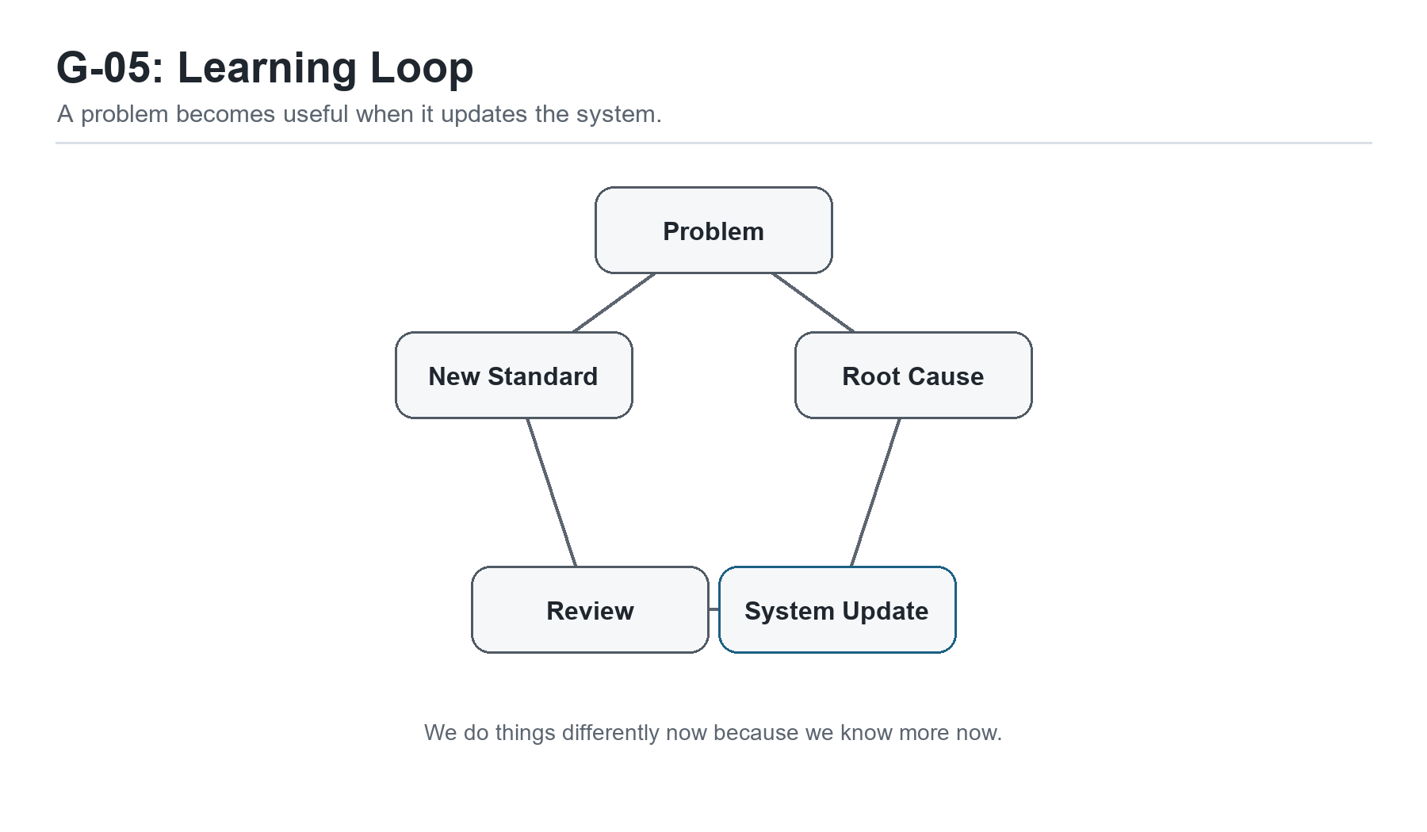
Figure G-05. Learning Loop. A problem becomes useful when it updates the system.
Hey partner, sooner or later something breaks again.
I wish I could tell you that once Sam mapped the business, removed some weight
from the work, respected his capacity, and started treating profit as a
practice, the business became smooth forever. That would be a comforting story.
It would also be dishonest.
Businesses are living systems. Customers change. Tools change. Team members
learn. Vendors miss deadlines. Offers get sharper. Markets get noisier. A
process that worked beautifully at one stage can start creaking at the next
one. Operational excellence is not the absence of problems. It is the habit of
learning from them before they become culture.
Sam learned that the hard way, but not in a dramatic way. A project simply
missed a handoff.
The client had approved the work. The files were in the right folder, or at
least everyone thought they were. The contractor had started, but not with the
latest notes. Sam had answered a customer question in email, then forgotten to
move that answer into the project record. The contractor made a reasonable
decision based on the information available. The client noticed the mismatch.
Nobody was trying to do poor work.
That matters.
When something breaks, the easiest thing is to look for the person closest to
the break and blame them. The contractor should have checked. Sam should have
remembered. The client should have clarified. The tool should have notified
someone. There may be truth in some of that, but blame is usually a poor
teacher. It makes people defend themselves instead of helping the business see.
So I asked Sam to slow down.
He wanted to fix it immediately, which was good. The customer needed care. But
after the customer was handled, the business needed a lesson. If we only patch
the moment, we may leave the pattern alive.
That is the doorway into a learning company.

Do Not Waste A Problem
Every problem carries information. That does not make problems pleasant. It
does not mean we should be careless so we have more to learn from. It means
that once a problem has happened, the business should not waste it.
Sam's first question was, "How do I keep this from happening again?"
That was a good question. But before we could answer it, we had to understand
what "this" really was. Was the problem that the contractor did not read the
notes? Was the problem that the notes were in the wrong place? Was the problem
that Sam had answered a customer question outside the project record? Was the
problem that no one owned final context before work started? Was the problem
that the business had no ready-to-start checkpoint?
If we name the problem too quickly, we usually fix the wrong thing.
A lot of businesses do that. They respond to a miss by adding a rule, sending a
stern message, buying a tool, or telling everyone to "communicate better."
Sometimes those moves help. Often they only add another layer of noise.
"Communicate better" is not a process.
"Be more careful" is not a system.
"Do not let this happen again" is not a root cause.
Those statements may express frustration, but they do not teach the business
how to behave differently next time.
So we treated the miss as a learning event.

The Five Whys Without The Theater
One simple method for learning from problems is the Five Whys. The idea is
straightforward: ask why something happened, then ask why again, and keep going
until you reach a cause that can actually be changed.
I like the method, but I do not like making it theatrical. We are not trying to
perform seriousness. We are trying to get closer to truth.
Sam and I wrote the issue at the top of the page:
The contractor started with outdated context.
Why?
Because the latest customer clarification stayed in Sam's email and did not
make it into the project record.
Why did it stay in email?
Because Sam answered quickly while moving between tasks and assumed he would
remember to update the record later.
Why was memory the bridge?
Because there was no rule for where customer clarifications belonged once a
project was active.
Why was there no rule?
Because the onboarding process had been improved, but the active-project
communication process had not been updated.
Why had that process not been updated?
Because the business had no regular habit for turning problems into SOP
changes.
Now we had something useful.
The root cause was not "contractor careless." It was not even simply "Sam
forgot." The deeper issue was that the system still depended on memory during
active delivery, and the business had no habit for updating the SOP when a
problem revealed a gap.
That is fixable.
The fix was not complicated. We added a rule: any customer clarification after
project start must be copied into the project record before the next work
block. We added an active-project context field. We added a quick review item
to the ready-to-work checklist: "Latest customer clarification captured?"
Small change. Real improvement.
That is how a company learns.

Root Cause Is Not A Witch Hunt
Root cause analysis can sound cold if we forget the people inside it. I want to
be careful here. A business should not use "root cause" language as a polite
way to corner someone.
The point is not to prove who failed.
The point is to understand what the system allowed, encouraged, hid, or failed
to support.
Sometimes the root cause includes a person making a poor choice. We should not
pretend otherwise. People have responsibility. Leaders have responsibility.
Founders have responsibility. But responsibility and blame are not the same
thing.
Responsibility asks, "What must we own so the work gets better?"
Blame asks, "Who can carry the discomfort so the rest of us can stop looking?"
A learning company chooses responsibility.
Sam had to own his part. He had kept the clarification in email. He had trusted
memory again. He had not made the active-project rule explicit. That did not
make him a bad founder. It made him the right person to improve the system.
He told the contractor, "This one is on the process. I answered the client and
did not move the update where you could see it. We are changing the checklist."
That sentence built trust.
Good operators do not hide from the truth. They make it usable.

The SOP Is A Living Document
Sam had thought of SOPs as final documents. You write them, store them, and
then feel a little guilty when nobody reads them.
That is not the kind of SOP I want you to build.
An SOP is not a trophy. It is a working agreement. It says, "This is how we do
the work now, based on what we currently know."
That last phrase matters: based on what we currently know.
If the business learns something new, the SOP should be allowed to change.
Otherwise the document becomes a museum of old assumptions.
I told Sam, "We do things differently now because we know more now."
That line gave him permission to update without shame. The old process was not
evil. It had simply reached the edge of what it could carry. The problem showed
us where the next version needed to be stronger.
This is one reason change logs matter. Not because the business needs paperwork
for its own sake, but because memory fades. A change log tells the future team
why the process changed. It keeps the business from repeating the same debate
six months later when everyone has forgotten the pain that taught the lesson.
A simple SOP update can include:
- What changed?
- Why did it change?
- Who owns the new step?
- Where does the work live?
- How will we know the change is working?
That is enough for many small businesses. Do not make the documentation heavier
than the work. The point is to make learning durable.

Feedback Is Not An Interruption
A learning company also needs feedback loops.
Feedback can come from customers, employees, contractors, vendors, metrics,
support tickets, complaints, reviews, sales objections, refunds, delays,
missed handoffs, and quiet friction. The business is always speaking. The
question is whether the founder has built a rhythm for listening.
Sam had been listening informally. If a client seemed frustrated, he noticed.
If a contractor asked the same question twice, he noticed. If a proposal went
cold, he felt it. But most of that feedback stayed in his head. It changed his
mood more often than it changed the system.
That is common.
A founder can be surrounded by signals and still have no learning loop.
So we created a simple weekly review. Not a long meeting. Not a corporate
ritual. Thirty minutes.
Every week, Sam would ask:
- What went well?
- What got stuck?
- What did a customer or lead tell us?
- What did we repeat that should become a checklist?
- What broke that should update the SOP?
- What is the one change we will actually make before next week?
The last question is the discipline. A review that produces ten ideas and no
change is only a conversation. A review that produces one real update teaches
the business to learn.

Innovation Starts Smaller Than Founders Think
When people hear innovation, they often think of big inventions, new products,
new technology, or a dramatic pivot. Those things can be innovation, but in a
small business, innovation often starts much smaller.
Innovation may be a better intake question.
It may be a proposal block that explains value more clearly.
It may be a checklist that prevents rework.
It may be a payment term that protects cash flow.
It may be a client handoff note that saves the contractor thirty minutes.
It may be a follow-up rhythm that turns quiet interest into a booked call.
It may be a decision to stop using a tool that no longer earns its place.
Small improvements compound because the business repeats them. A one-time
effort helps once. A better system helps every time the work passes through it.
Sam liked this because it made improvement feel reachable. He did not need to
become a different kind of founder overnight. He needed to notice one friction,
learn from it, and update one part of the system.
Then do it again.

Experiments Beat Arguments
A learning company does not have to settle every question by debate.
Some questions need judgment. Some need values. Some need customer
conversation. But many questions can be answered by a small experiment.
Sam had been debating whether to build a more polished lead nurture sequence,
buy a tool, redesign his website, or focus on direct outreach. Each option had
arguments in its favor. That is why founders get stuck. A smart person can make
a case for almost anything.
So we narrowed the question.
What is the smallest test that would create useful truth?
Not the most impressive test. Not the most automated test. Useful truth.
Could Sam send five thoughtful emails to people who already had some reason to
care? Could he post one practical lesson publicly? Could he ask three past
customers what made them trust him? Could he offer a paid diagnostic before
building a full program? Could he invite ten founders to a small roundtable
before creating a full event machine?
Small experiments protect founders from fantasy. They also protect them from
overbuilding.
If the test produces signal, keep learning. If it produces silence, learn from
that too. The goal is not to be right on the first try. The goal is to become
less wrong faster and more honestly.
That is not failure. That is operation.

Learning From Success
Founders often study failure more carefully than success. That is
understandable. Failure hurts, so it gets attention. But success deserves
analysis too.
When something works, ask why.
Why did that customer say yes?
Why did that post get replies?
Why did that project finish smoothly?
Why did that invoice get paid without chasing?
Why did that contractor perform well?
Why did that conversation create trust?
Success can teach the system what to repeat. If the business does not study
success, it may treat good outcomes as luck and fail to build on them.
Sam had one client project that had gone unusually well. At first he described
it as "just a good client." That may have been partly true, but we looked
closer. The project had started with a clearer scope. The client had answered
intake questions quickly. Sam had sent a confirmation note before starting.
The contractor had all the files in one folder. The invoice was tied to a clear
milestone.
That was not just a good client. That was a better pattern.
We turned that pattern into a checklist.
Learning from success is how a business becomes intentionally good instead of
occasionally lucky.

Leadership Commitment
A company does not learn by accident. The leader has to make learning normal.
That does not mean the leader has to have every answer. In fact, the opposite
is usually healthier. The leader has to be willing to say:
I missed that.
We know more now.
Let us update the system.
What did the customer teach us?
What did the numbers teach us?
What did the team see that I did not see?
What will we do differently next time?
Those questions create room for truth. They tell the team that the goal is not
to protect the founder's ego. The goal is to protect the work, the customer,
and the business.
Sam was still learning this. Most founders are. When the business feels
personal, every problem can feel like a verdict. A missed handoff feels like,
"I am bad at this." A slow month feels like, "The business is failing." A
customer complaint feels like, "I should have known better."
But the learning company gives the founder a better sentence:
"The system is telling us where to update."
That sentence does not remove responsibility. It makes responsibility usable.

Operator Checkpoint: The Learning Loop
Here is a simple learning loop you can use this week.
Choose one recent event. It can be a problem, a success, a reply, a complaint,
a missed invoice, a smooth project, or a sales conversation.
Then answer:
- What happened?
- What did we expect to happen?
- Where did reality differ from the expectation?
- Why did that difference happen?
- What does the system need to change?
- Who owns the change?
- When will we check whether it worked?
Keep it small. One event. One change. One owner. One review date.
If you do that every week, your business will begin to accumulate wisdom in
the system instead of leaving it scattered across memory, stress, and old
messages.

What Sam Noticed
Sam began the chapter thinking operational excellence meant getting the system
right.
By the end, he understood something better.
Operational excellence means building a company that can keep getting more
right as it learns.
That is a different kind of hope. It is not the fragile hope that says nothing
will break. It is the sturdier hope that says when something breaks, we can
listen, learn, repair, and improve.
The business does not have to be perfect to be trustworthy.
It has to be honest enough to see, humble enough to learn, and disciplined
enough to update.
That is how a founder grows into an operator. That is how a small business
becomes less dependent on heroic memory. That is how the company begins to
carry its own lessons forward.
Sam looked back at the first customer request we had mapped together. At the
time, it had felt like evidence that the business was messier than he wanted
to admit. Now he saw it differently. It was the first lesson the business had
offered him once he was willing to listen.
The business had been speaking the whole time.
Now Sam had a way to answer.

Chapter Takeaway
A learning company does not avoid every problem. It turns truth into updated
practice before the same problem becomes culture.

Chapter 6: The Rhythm That Keeps the Business Alive
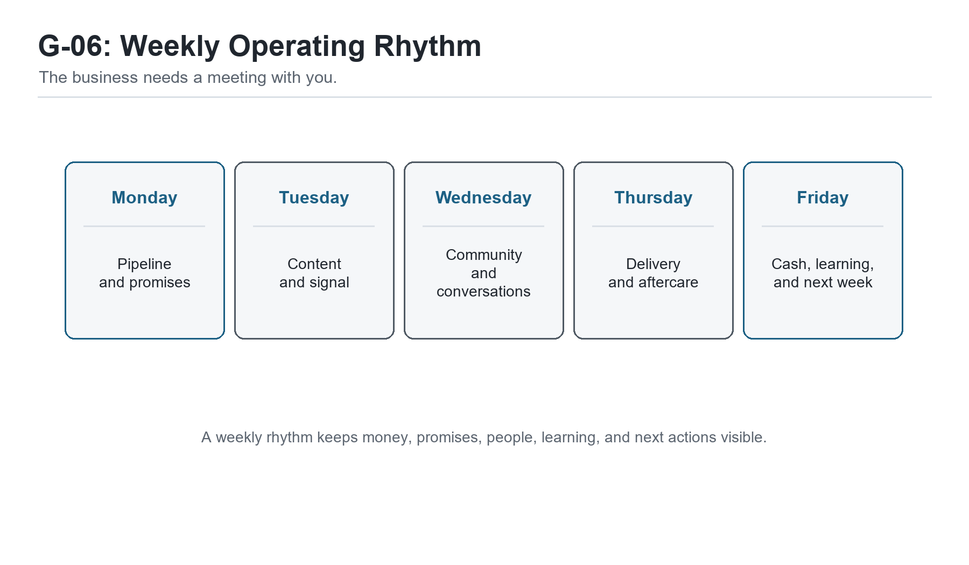
Figure G-06. Weekly Operating Rhythm. The business needs a meeting with you.
Hey partner, a system you do not revisit will slowly become a memory.
That was Sam's next lesson. He had learned a lot by now. He could see the
business more clearly. He had removed some unnecessary weight. He understood
that people, time, and tools were not infinite. He had started treating profit
as breathing room. He had learned how to turn problems into updates instead of
blame.
But there was still a danger.
All of that learning could fade if it did not become rhythm.
Founders often think the hard part is building the system. That is only half
true. Building matters. A clear workflow matters. A useful tracker matters. A
good checklist matters. But the system only stays alive if the founder returns
to it on purpose.
Sam had been through this before. He had created a few good documents in the
past. A project board. A proposal template. A notes folder. A client checklist.
They helped for a while, then the press of the week took over. The urgent work
got loud, and the operating system got quiet.
That is not because Sam was unserious. It is because a small business has
gravity. It pulls the founder back toward the inbox, the customer request, the
problem of the day, the tool that is blinking, the bill that is due, the
message that feels easiest to answer.
Without rhythm, the business drifts back toward reaction.
So I told Sam, "Now we have to decide when the business gets heard."

The Business Needs A Meeting With You
That sentence made Sam smile. It sounded strange at first.
The business needs a meeting with you.
But it is true. The business is always speaking through leads, invoices,
customer questions, missed handoffs, open proposals, tool friction, delivery
delays, cash pressure, and small wins. If the founder never gives those signals
a place to gather, they scatter across the week. Then the founder feels them
as anxiety instead of reading them as information.
Most small businesses do not need more meetings. They need better rhythm.
A meeting can be wasteful. A rhythm is different. A rhythm is a repeating
appointment with reality. It keeps the founder from having to rediscover the
same truth over and over.
Sam did not need a corporate operating cadence with five dashboards and a stack
of reports. He needed a simple weekly rhythm that fit the size of his business
and protected the work that mattered most.
We started with five questions:
- What brings money in?
- What keeps promises to customers?
- What protects cash?
- What teaches the business?
- What must be decided before the next week starts?
Those questions became the spine of the rhythm.

Monday: Pipeline And Promises
Monday was for pipeline and promises.
Not because Monday is magical. It is not. But the beginning of the week is a
good time to look at what is open before the week starts making decisions for
you.
Sam's Monday rhythm was simple:
- review active leads
- review open proposals
- review follow-ups due
- review current client promises
- choose the most important revenue action of the week
That last item mattered most.
A founder can review a tracker and still avoid the action. The tracker is not
the work. The tracker points to the work. If a proposal needs follow-up, the
work is the follow-up. If a lead needs a reply, the work is the reply. If a
client promise is at risk, the work is protecting the promise.
Sam had a habit of letting Monday become cleanup day. He would answer email,
open tools, reorganize notes, check tasks, and call it preparation. Some of
that had value. But if Monday ended without a revenue action or a promise
protected, the business had not really been served.
So we made the Monday rule plain:
Before noon, one revenue action has to move.
That could be a follow-up, a proposal, a direct outreach note, a referral ask,
or a diagnostic invitation. It did not have to be dramatic. It had to be real.

Tuesday: Content And Signal
Tuesday was for content and signal.
Sam had resisted content because it felt like performance. I understood that.
A lot of founders do not want to become full-time broadcasters. They want to
work. They want to serve. They want to build something useful.
But content does not have to be theater.
At its best, content is a public learning trail. It shows what the founder is
seeing, what the business believes, what problem it solves, what tradeoffs it
understands, and who it can help.
For Sam, Tuesday content was not about chasing every platform. It was about
turning real work into useful signals. A lesson from a client project. A
question founders should ask. A mistake avoided. A checklist. A short story
about a workflow getting lighter. A note about the wall at the end of free
tools.
The Tuesday rhythm had three parts:
- Publish or prepare one useful piece.
- Connect it to a clear next step.
- Watch for signal.
The next step mattered. Content without a next step creates awareness that has
nowhere to go. That next step did not always have to be a sale. It could be a
reply, a question, a diagnostic, a roundtable, a worksheet, a short call, or a
simple "message me if you want the checklist."
Sam learned to ask, "If someone cares about this, what should they do next?"
That question turned content from expression into movement.

Wednesday: Community And Conversations
Wednesday was for community and conversations.
Every business has a market, but not every business has a community. A market
is where people buy. A community is where people recognize each other's
problems, language, hopes, and constraints.
Sam did not need to build a giant community. He needed to stop treating every
lead as a lonely transaction. Founders talk. Operators compare notes. Clients
know other clients. Local business owners remember who showed up with useful
help before asking for the sale.
So Wednesday became the day for relationship work:
- check in with past customers
- ask for referrals where trust already exists
- invite founders to a small conversation
- follow up with people who engaged with content
- look for partnerships that make the work easier or more useful
The key word is useful.
Community work is not collecting names. It is creating places where the right
people can see the problem more clearly together.
Sam's first version was small. He invited a few founders to a simple roundtable
question: "Where is your tool stack making the business heavier instead of
lighter?"
That question did two jobs. It helped the founders. It also taught Sam where
the market was feeling pain. A good community rhythm should do both.

Thursday: Delivery And Aftercare
Thursday was for delivery and aftercare.
This was the day Sam looked at the promises already made. Not the future
pipeline. Not the next idea. The work already entrusted to the business.
Founders who are hungry for revenue can accidentally treat delivery as the
thing that happens after the sale. That is dangerous. Delivery is where trust
is either confirmed or damaged. Aftercare is where a one-time customer can
become a long-term relationship, a referral source, or a lesson.
Sam's Thursday rhythm included:
- review active projects
- check ready-to-work status
- confirm open customer questions
- review delivery risks
- send one proactive update
- capture one improvement for the SOP
- identify one aftercare opportunity
The proactive update became one of his best habits.
Many customers do not need perfection. They need not to be left wondering.
Silence creates stories. A simple update can prevent a customer from filling
the silence with worry.
Aftercare also changed how Sam saw completed work. A project was not done just
because the deliverable was sent. The business still needed to ask:
Did the customer get the outcome?
Is there anything to adjust?
What did we learn?
Is there a next problem we can help solve?
Would a testimonial, referral, or case note be appropriate?
That is not manipulation. It is stewardship after the promise.

Friday: Cash, Learning, And Next Week
Friday was for cash, learning, and next week.
This became Sam's breathing-room review. Not a punishment. Not a shame
session. A review.
He looked at:
- invoices sent
- invoices due
- unpaid balances
- upcoming expenses
- tool subscriptions
- revenue actions completed
- signals from content and outreach
- delivery lessons
- the one operating change to carry into next week
Cash belongs in the weekly rhythm because a founder should not only meet the
truth of money when the account feels scary. Money should be reviewed while the
founder can still act.
Learning belongs in the weekly rhythm because lessons spoil when they sit too
long. The missed handoff, the customer question, the reply that surprised you,
the post that landed, the proposal that went quiet - each one has information
inside it.
Next week belongs in the weekly rhythm because Monday should not begin with the
founder wandering into the fog.
Sam's Friday question was:
What do I need future me to know before next week starts?
That question was kinder than it sounded. It treated the founder as a person
with limited memory and limited energy. It stopped asking Monday Sam to clean
up everything Friday Sam refused to decide.

The Dashboard Should Be Boring
Once the rhythm was clear, Sam wanted to build a dashboard.
That was fine, but I gave him a warning:
The dashboard should be boring.
Founders sometimes build dashboards that look impressive and tell them very
little. Colorful charts, ten tabs, complicated formulas, metrics nobody uses,
and a sense of control that disappears the moment a customer calls.
A small-business dashboard should answer the few questions that matter every
week.
For Sam, the first version tracked:
- new leads
- follow-ups due
- booked calls
- proposals sent
- active projects
- invoices due
- cash received
- content published
- useful replies or objections
- one operating improvement
That was enough.
The goal of the dashboard was not to admire the dashboard. The goal was to
make decisions easier. If a number did not help Sam act, we did not need it in
the first version.
This is another place where founders can overbuild. A dashboard can become a
place to hide from the uncomfortable action. If the tracker says three people
need follow-up, the work is not to improve the tracker. The work is to follow
up.
The dashboard is a window. Do not polish the window while the house is on
fire.

The Weekly Scoreboard
Sam liked games, so we built a small scoreboard.
Not to turn the business into a toy. To make progress visible.
The scoreboard had two kinds of measures: activity and signal.
Activity measures whether Sam did the controllable work:
- outreach sent
- follow-ups completed
- content published
- invoices sent
- customer updates delivered
- SOP improvements made
Signal measures whether the world responded:
- replies
- booked calls
- referrals
- proposal opens
- paid invoices
- objections
- repeat inquiries
- testimonials
Both matter, but they should not be confused.
If activity is low, the founder has not given the market enough chances to
respond. If activity is steady but signal is low, the founder has something to
learn about the audience, offer, message, timing, or channel. If signal is
high and capacity is breaking, the founder has earned the next system upgrade.
That is why the scoreboard connects back to the Bootstrap Limit Wall. The
business should not guess when it is time to upgrade. The rhythm should reveal
it.

Do Less, More Reliably
At this point, Sam had a list of possible rhythms, metrics, dashboards, and
reviews. He could feel the old danger rising. The danger was turning a simple
operating rhythm into another heavy system.
So I gave him a phrase:
Do less, more reliably.
That phrase is not an excuse for small thinking. It is a protection against
fragile ambition.
A founder can always imagine a more complete system. More metrics. More
content. More automations. More offers. More channels. More reports. More
meetings. But the best system is not the one that looks complete on paper. The
best system is the one the business actually uses when the week gets hard.
Sam's first weekly rhythm fit on one page.
Monday: pipeline and promises.
Tuesday: content and signal.
Wednesday: community and conversations.
Thursday: delivery and aftercare.
Friday: cash, learning, and next week.
That was enough to start.

Operator Checkpoint: Build Your Weekly Rhythm
Use this checkpoint to build a rhythm you can actually keep.
Choose one day for each operating concern:
- Pipeline: leads, proposals, follow-up, booked calls.
- Marketing: content, CTA, audience signal.
- Relationships: referrals, community, partnerships, past customers.
- Delivery: active promises, quality, customer updates, aftercare.
- Finance and learning: invoices, cash, expenses, lessons, next week.
Then answer:
- What is the one action that must happen on this day?
- What tracker or document shows the truth?
- What decision should be made before the day ends?
- What can be ignored for now?
- How will we know this rhythm is helping?
Keep the rhythm visible. Put it where the week begins. Do not hide it inside a
tool nobody opens.
And remember: the rhythm is allowed to change. If Wednesday becomes a bad day
for relationship work, move it. If Friday finance review needs to happen
Thursday morning, adjust. The point is not to worship the calendar. The point
is to make sure the business keeps being heard.

What Sam Noticed
After a few weeks, Sam did not feel magically calm every day. That would not be
real. Business still had pressure. Customers still needed things. Money still
mattered. Tools still had limits. Some weeks still got messy.
But the mess no longer had the same power.
Monday gave the pipeline a place.
Tuesday gave the message a place.
Wednesday gave relationships a place.
Thursday gave delivery a place.
Friday gave cash and learning a place.
The rhythm did not solve everything. It made the business less dependent on
panic.
Sam started noticing issues sooner. He followed up more reliably. He stopped
forgetting invoices as often. He captured lessons before they faded. He saw
which tools were earning their place and which ones were only adding weight.
He had a better answer when someone asked what the business needed next.
That is what rhythm does. It turns scattered responsibility into a repeated
practice.
Near the end of one Friday review, Sam looked at the one-page rhythm and said,
"This is not fancy."
I said, "Good."
Fancy is not the goal. Alive is the goal.
A living business does not need a perfect operating system. It needs a rhythm
that keeps truth moving through the work.

Chapter Takeaway
The system stays alive when the business has a weekly rhythm for money,
promises, people, learning, and the next right action.

Chapter 7: Building a Business That Can Be Trusted
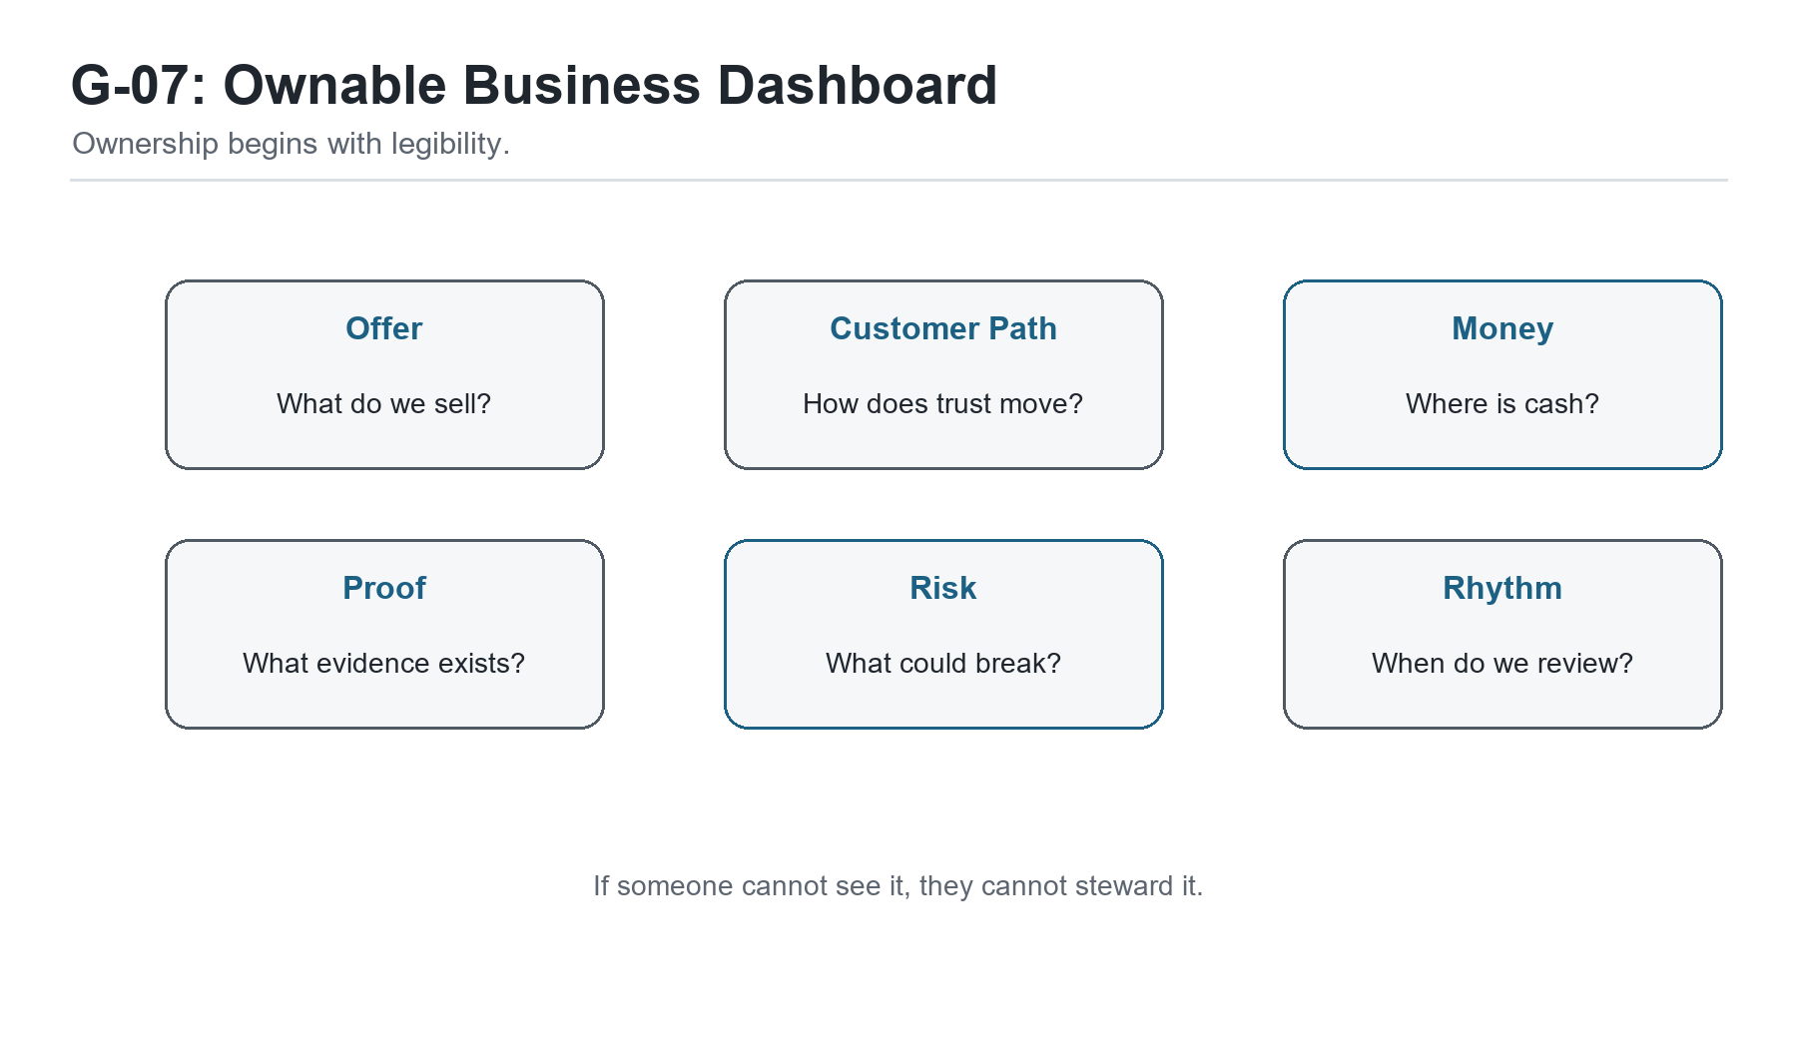
Figure G-07. Ownable Business Dashboard. Ownership begins with legibility.
Hey partner, there is a difference between a business that depends on you and
a business that can be trusted.
That difference became clearer to Sam after he had lived with the weekly
rhythm for a little while. The business was still small. It still needed him.
It still carried his judgment, his relationships, his standards, his care, and
his name. Nothing about operational excellence had made Sam unnecessary.
That was never the goal.
The goal was to stop making Sam the only place the business lived.
In the beginning, the business had lived mostly in his head. Leads lived in his
memory. Customer details lived in old messages. Follow-ups lived in good
intentions. Quality standards lived in his instincts. Lessons lived in the
feeling of what had gone wrong last time. Cash flow lived in anxiety until he
looked at the account.
Now more of the business had a place.
The customer path had a map. The work had a lighter workflow. Capacity had a
more honest boundary. Profit had become a practice. Problems had a learning
loop. The week had a rhythm.
Sam looked at me one afternoon and said, "It feels less like I am dragging the
business behind me."
That is a good sign.
But it raised the next question.
If the business is not only in the founder's head, where does it live?

Trust Has To Be Built Into The Work
A business becomes trustworthy when people can rely on it without needing one
person to remember everything.
That does not mean the business becomes cold. It does not mean customers stop
feeling personally cared for. It means the care becomes more dependable.
A customer should not have to hope Sam remembers the next step.
A contractor should not have to guess which file is current.
A partner should not have to wonder whether the promise was written down.
A future team member should not have to absorb the business by shadowing Sam
for six confusing months.
And Sam should not have to wake up every morning as the living backup drive for
the company.
That is what trust means operationally. The business can keep a promise
because the promise has a path.
We had already built pieces of that path. Now Sam needed to see the larger
meaning. He was not just getting organized. He was making the business more
ownable.
Ownable does not mean sold tomorrow. It does not mean investor-ready tomorrow.
It does not mean the founder is trying to leave. It means the business is
becoming clear enough that its value can be understood, improved, protected,
and eventually transferred if the founder chooses.
Ownership begins with legibility.
If no one can tell how the business works, the business is hard to own. Even
the founder only owns it by force of presence. But when the work, numbers,
relationships, risks, and rhythms become visible, the business becomes more
than a job wrapped around one person.
It becomes an asset in formation.

The Founder Is Not The Product
This was a tender point for Sam.
Many service founders are the product at first. Customers buy because they
trust the founder. They like the founder's taste, judgment, speed, reputation,
or care. That is not wrong. It is often how a business begins.
But if the founder remains the entire product forever, the business can only
grow as far as the founder can personally stretch.
Sam had felt that. If he was tired, the business slowed down. If he was
distracted, follow-up slipped. If he was sick, delivery got nervous. If he
wanted to take a day off, the work followed him anyway.
That is not freedom. That is dependence with invoices.
So I asked Sam a question:
What part of your value can become a standard?
Not what can become generic. Not what can be stripped of personality. What can
become a standard?
His care could become a customer update rhythm.
His judgment could become a diagnostic checklist.
His quality instinct could become a review step.
His sales conversations could become a clearer offer ladder.
His delivery memory could become a ready-to-work checklist.
His learning could become an SOP update log.
His founder voice could become a content rhythm.
When a founder turns judgment into standards, the business does not lose soul.
It gains reliability.
The founder is still important. But the founder is no longer the only way the
business knows how to be itself.

What Makes A Business Ownable
Sam asked me what I meant by ownable in practical terms.
I told him an ownable business is one that can be understood by someone other
than the founder without destroying what made it valuable.
That understanding has several layers.
First, the business needs a clear offer. What problem does it solve? For whom?
What result does it create? What should people not hire it for? If the offer is
fuzzy, everything downstream gets heavier.
Second, the business needs a visible customer path. How does someone move from
first awareness to inquiry, conversation, proposal, payment, delivery,
aftercare, and repeat engagement? If the customer path is invisible, revenue
depends too much on luck and memory.
Third, the business needs operating rhythms. Who reviews pipeline? Who watches
cash? Who protects delivery? Who captures lessons? If there is no rhythm,
truth arrives late.
Fourth, the business needs financial clarity. What does it cost to deliver the
work? Which offers create margin? Which clients or projects drain capacity?
Which tools earn their place? If the money is foggy, ownership is fragile.
Fifth, the business needs documented standards. Not a giant binder. Standards.
How do we start work? How do we review quality? How do we update customers?
How do we handle a complaint? How do we close the loop after delivery?
Sixth, the business needs proof. Testimonials, case notes, outcomes, replies,
referrals, reviews, before-and-after stories, and clean records. Proof is how
trust travels beyond the founder's immediate presence.
Seventh, the business needs a learning loop. If the business cannot update
itself, it will eventually become stale, brittle, or dependent on crisis.
None of these pieces has to be perfect. But each one makes the business easier
to understand, easier to improve, and easier to trust.
That is the path from hustle to stewardship.

Stewardship Is Different From Control
Founders often confuse control with stewardship.
Control says, "I have to touch everything so it turns out right."
Stewardship says, "I have to build the conditions that help the right things
happen reliably."
Control can feel responsible, but it can become a cage. It keeps the founder
in the middle of every decision, every handoff, every customer question, every
quality check, every tool, every exception. The founder becomes the bottleneck
while believing he is protecting the business.
Stewardship still cares deeply. It may care more. But it expresses care
differently. It builds standards. It creates visibility. It trains people. It
updates the system. It names risk early. It protects cash. It respects the
customer. It makes the business less dependent on panic.
Sam had been controlling more than he realized. Not because he wanted power.
Because he loved the work and did not want to disappoint people.
That is common.
I told him, "Sometimes the founder keeps everything close because he cares.
Then the business starts to suffer because everything is too close."
Care has to mature into stewardship.
That is one of the quiet transitions in entrepreneurship. At first, the founder
proves the promise by carrying it personally. Later, the founder protects the
promise by building a system that can carry more of it.

The Exit Question Is Not Only About Selling
Sam got uncomfortable when I used the word transferable.
He said, "I am not trying to sell the business."
I understood. A lot of founders hear exit language and think it belongs to
venture capital, acquisition decks, private equity, or people who are already
planning to leave.
But transferability is not only about selling.
A transferable business gives the founder options.
It can survive a vacation.
It can onboard help.
It can pass work to a contractor without losing quality.
It can bring in a partner.
It can train a manager.
It can survive a hard month.
It can support a family.
It can be valued more clearly if funding, sale, succession, or partnership
ever becomes relevant.
It can even stay small on purpose, but healthier.
That is why the exit question matters even if you never sell:
Could someone else understand enough of this business to protect what matters?
If the answer is no, the founder does not have to panic. But he should know
where the opacity lives.
What only exists in your head?
What only works because you push it?
What only gets done because you remember?
What only sells because you explain it live every time?
What only stays profitable because you ignore your own unpaid labor?
Those are not accusations. They are signposts.

Risk Lives In What Nobody Can See
The invisible parts of a business carry risk.
An unwritten process is a risk.
An unclear owner is a risk.
An untracked follow-up is a risk.
A verbal-only promise is a risk.
A tool no one maintains is a risk.
A price that does not include true cost is a risk.
A founder who is the only person who understands delivery is a risk.
Risk does not mean disaster is guaranteed. It means the business is exposed.
Sam had been thinking about risk mostly as bad events: losing a client, missing
a deadline, running out of money, hiring the wrong person. Those are real. But
many of those events are downstream from smaller invisible risks.
The purpose of operational excellence is not to make the business afraid. It
is to make risk visible early enough that the founder can act.
Once a risk is visible, it can be reduced, accepted, priced, insured, assigned,
scheduled, documented, or watched.
Invisible risk just waits.

Proof Makes Trust Portable
If standards make the business more reliable, proof makes trust portable.
This was another important lesson for Sam. He had happy customers, but much of
that trust stayed private. A nice message here. A thank-you there. A referral
that happened informally. A customer outcome Sam remembered but never wrote
down.
That kind of proof helps the founder emotionally, but it does not help the
business as much as it could.
Proof needs a place.
A testimonial. A short case note. A review. A before-and-after story. A metric
when a metric is honest. A customer quote with permission. An internal proof
log. A sales note that captures the objection someone overcame. A delivery
note that records what worked.
This is not about bragging. It is about making trust easier to share.
When a future customer asks, "Can you help someone like me?" proof answers.
When a partner asks, "What do you actually do?" proof answers.
When the founder gets discouraged and forgets that the work matters, proof
answers.
When the business needs funding or a paid tool, proof helps explain why the
next investment is grounded in reality.
Sam started a simple proof log. Nothing fancy. Date, customer or lead, signal,
category, permission status, and next use. Some entries were public. Some were
private. Both mattered.
The business was learning to carry its own credibility.

The Owner's Dashboard
At this stage, Sam's dashboard needed one more layer.
The weekly dashboard helped him run the business. The owner's dashboard helped
him understand the business.
The difference is subtle but important.
The weekly dashboard asks, "What needs action this week?"
The owner's dashboard asks, "Is this business becoming stronger?"
For Sam, the owner's dashboard stayed simple:
- Revenue received.
- Gross margin by offer.
- Leads added.
- Conversations booked.
- Proposals sent.
- Active delivery promises.
- Invoices due.
- Proof captured.
- SOPs updated.
10. Top current risk.
That last line mattered: top current risk.
Every month, Sam had to name one. Not twenty. One. The risk could be cash,
capacity, lead flow, tool dependency, delivery quality, customer concentration,
pricing, or founder burnout. Naming one risk did not solve everything, but it
gave the founder a place to act.
The owner's dashboard should not become another burden. It should be a mirror.
It should help the founder ask, "Is the business becoming more trustworthy,
more legible, and more durable?"

Operator Checkpoint: The Ownable Business Review
Use this checkpoint when you want to know whether your business is becoming
more ownable.
Ask:
- Can I explain the offer in one clear paragraph?
- Can I show the customer path from first contact to aftercare?
- Can someone find the current status of leads, projects, and invoices without
asking me?
- Do our prices include the real cost of delivery, support, tools, admin, and
founder time?
- Do we have a weekly rhythm for pipeline, delivery, finance, and learning?
- Do we update SOPs when problems or successes teach us something?
- Do we capture proof when the work creates trust?
- What part of the business still lives only in my head?
- What risk is invisible right now?
10. What would make the business easier to trust next month?
Do not use this checklist to shame yourself.
Use it to choose the next improvement.
A business becomes ownable one visible piece at a time.

What Sam Noticed
Sam did not suddenly become detached from the business. He still cared. He
still had preferences. He still wanted customers to feel the difference in how
he worked. He still knew that his own voice and judgment were part of the value.
But the business no longer felt like it would disappear if he stopped staring
at it for a moment.
That was new.
He could see the lead path. He could see the delivery path. He could see the
money more clearly. He could see what tools were doing. He could see which
lessons had become standards. He could see proof beginning to accumulate.
He was not just building a job.
He was building something that could be understood.
That is where trust begins to compound.
First the founder trusts the system enough to stop carrying everything in his
head.
Then the customer trusts the business because the experience becomes more
reliable.
Then the team or contractor trusts the process because the work is clearer.
Then partners trust the business because the offer and proof are easier to
explain.
Then future options open because the value is no longer trapped entirely
inside the founder's presence.
Sam looked at the work on the table and said, "This feels like the business is
becoming real."
It had always been real. But now it was becoming legible.
That is a different kind of milestone.

Chapter Takeaway
A business becomes ownable when its value, promises, proof, risks, and rhythms
are visible enough for trust to travel beyond the founder.

Chapter 8: The Founder Becomes the Steward
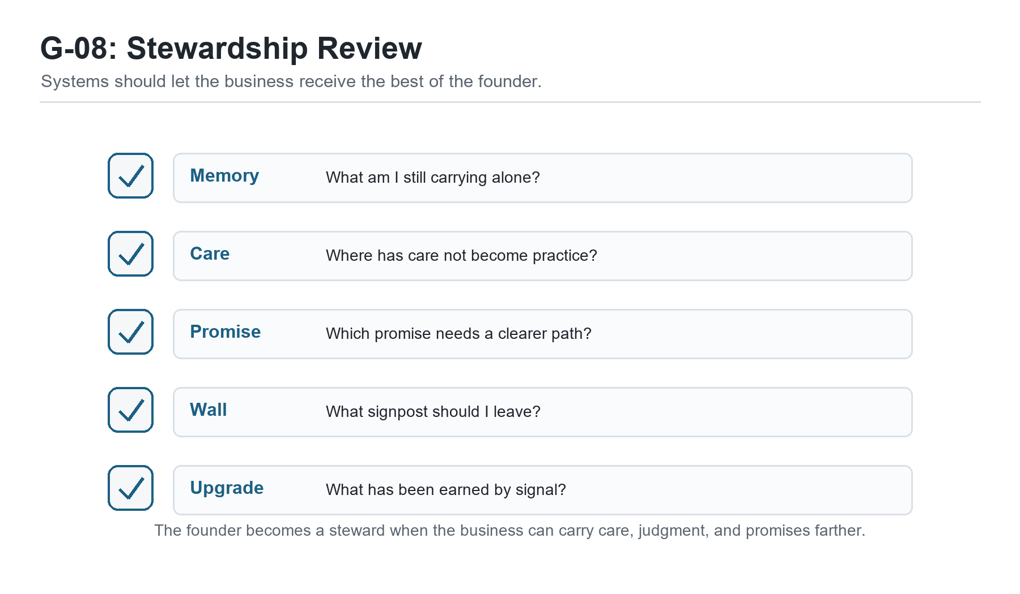
Figure G-08. Stewardship Review. Systems should let the business receive the best of the founder.
Hey partner, the business changes the founder too.
That may be the quietest truth in this whole book. We start by trying to build
a business, but if we are paying attention, the business starts building
something in us. It teaches us what we avoid. It shows us where we overpromise.
It reveals how we handle pressure, money, people, disappointment, attention,
and trust.
Sam had changed.
He was still Sam. He still had too many ideas some days. He still had moments
when the inbox pulled him off course. He still got excited about a new tool
before asking whether the old process was clear. He still felt the pressure of
cash and the responsibility of customers.
But something had shifted.
At the beginning, Sam had been carrying the business like a backpack full of
loose parts. Leads, notes, tools, promises, customer details, and half-formed
plans all rattled around together. He was not failing because he lacked heart.
He was struggling because his care had no reliable container.
Now the business had more shape.
Not perfection. Shape.
And shape gives a founder room to become a different kind of leader.

The Founder Who Carries Everything
In the early stage, the founder carries almost everything.
That is not always wrong. Sometimes it is necessary. The founder has to learn
the customer. The founder has to feel the work. The founder has to hear the
objections directly. The founder has to make promises carefully and discover
what delivery really costs.
There is wisdom in staying close to the work.
But carrying everything is not the same as understanding everything.
When a founder carries everything without structure, the business gets heavy
in a way that is hard to explain. The founder feels responsible for every
detail but cannot see the whole system. He answers messages, fixes problems,
remembers exceptions, makes decisions, pays bills, follows up, delivers work,
and then wonders why the business still feels fragile.
That was Sam at the start.
He thought he needed more discipline. He did need discipline, but not the kind
that shames a person into working later. He needed operating discipline: the
practice of making truth visible, choosing the next right action, and updating
the system as the business learned.
The founder who carries everything is not weak. He is usually under-supported
by the business he created.
That distinction matters. Shame says, "I am not enough." Operational truth
says, "The system is asking one person to carry too much."

Stewardship Begins With Seeing
Stewardship begins when the founder stops confusing pressure with leadership.
Pressure is loud. It says answer this now, fix this now, chase this now, buy
this now, worry about this now. Leadership has to listen, but it cannot obey
every noise.
Sam's first act of stewardship was seeing the business honestly. Not the dream
version. Not the ashamed version. The real version. The customer path, the
workflow, the capacity, the cost, the learning loop, the rhythm, the proof, the
risk.
That kind of seeing changes the founder.
It makes the work less mystical. It also makes excuses harder. Once the path is
visible, the founder can no longer say, "I do not know why follow-up keeps
slipping," when the tracker shows no owner or date. Once cash is visible, the
founder can no longer pretend pricing is fine if every project drains margin.
Once the customer path is visible, the founder can no longer blame marketing
for what delivery does not support.
That may sound uncomfortable. It is.
But it is also freeing.
Truth that can be seen can be served.
Truth that stays hidden becomes a weight the founder carries alone.

The Servant Leader Builds Capacity
I want to be careful with the phrase servant leadership because people can turn
it into decoration. They put it on a wall, say it at a meeting, and then keep
building systems that exhaust people.
That is not what I mean.
Servant leadership is not being soft on reality. It is using capability in
service of the work, the people, and the mission. It asks the founder to build
conditions where others can do good work without being crushed by confusion.
For Sam, servant leadership looked practical.
It meant not making the contractor guess.
It meant not making the customer wonder.
It meant not making future Sam remember what current Sam refused to write down.
It meant not making the business dependent on unpaid emotional labor.
It meant not buying tools to avoid hard conversations.
It meant not pretending underpricing was generosity when it starved the
business.
It meant building capacity.
Capacity is not only about doing more. Sometimes capacity is about doing less
with more clarity. Sometimes it is about saying no before the business breaks.
Sometimes it is about pricing honestly. Sometimes it is about writing the
checklist. Sometimes it is about admitting the free tool has done its job and
the business has earned the next paid layer.
The servant leader does not serve chaos. The servant leader serves people by
reducing chaos where it can be reduced.

The Business As A Trust Machine
At its best, a business is a trust machine.
That phrase might sound mechanical, but I mean it with warmth. A good business
takes trust and turns it into kept promises. A customer trusts the business
with money, attention, time, access, hope, or a problem they cannot solve
alone. The business receives that trust and turns it into action.
If the business keeps the promise, trust grows.
If the business drops the promise, hides the problem, or leaves people
wondering, trust shrinks.
Operational excellence is how trust gets treated with respect.
The proposal should match the delivery.
The delivery should match the promise.
The invoice should match the agreement.
The follow-up should match the relationship.
The tools should support the work.
The rhythm should keep truth moving.
The proof should help trust travel.
Sam began to see that operations were not separate from care. They were one of
the ways care became real.
A founder can care deeply and still create a confusing customer experience.
Care has to become practice if it is going to be felt reliably by someone else.
That is what Sam was building.

The Next Founder Behind You
One afternoon, after we had reviewed the weekly rhythm and the ownable business
checklist, Sam said something that told me the lesson had gone deeper than his
own company.
He said, "I wish someone had shown me the wall earlier."
He was talking about the Bootstrap Limit Wall, but he was also talking about
all of it. The moment when free tools stop stretching. The moment when the
founder has motion but no margin. The moment when follow-up starts breaking.
The moment when busy does not feel safe. The moment when the founder is doing
real work and still wondering if the business can carry him.
A lot of entrepreneurs end there.
They hit the wall and think it means they are done. Or they scrounge for
funding without knowing what the funding is supposed to remove. Or they buy a
tool because buying feels like progress. Or they keep grinding until the body,
the family, or the bank account refuses to keep lending them time.
Sam was beginning to see that the wall should be mapped.
Not only for him.
For the next founder behind him.
That is what experience is for. We do not only survive hard places so we can
feel proud. We survive them, name them, and leave signposts if we can.
A signpost says:
This is motion, not yet signal.
This is signal, not yet scale.
This is a manual bridge, not a permanent structure.
This is the funding trigger.
This is the place to sell before you spend.
This is the place to upgrade because demand has earned it.
This is the place to stop and learn before you build heavier.
When a founder leaves those signs, the road becomes less lonely for someone
else.

Growth Without Losing The Soul
Sam had been afraid that systems would make the business less personal.
By now, he understood the opposite could be true.
Bad systems can make a business cold. Overbuilt systems can make people feel
processed instead of served. Tools can create distance when they are used to
avoid human responsibility.
But good systems protect the soul of the business.
They protect the founder from exhaustion.
They protect the customer from confusion.
They protect the team from guessing.
They protect the promise from being lost in scattered messages.
They protect the business from mistaking chaos for authenticity.
The soul of the business is not the mess. The soul is the reason the work
matters and the way people should feel cared for when they encounter it.
A system that helps the business care more reliably is not a betrayal of the
soul. It is service to it.
That was a major turn for Sam. He stopped seeing operations as the opposite of
his original vision. He started seeing operations as the way the vision could
survive contact with real customers, real bills, real limits, and real growth.

The Founder Is Allowed To Be Human
I want to say something plainly here.
The founder is allowed to be human.
That may sound obvious, but many businesses are quietly built on the opposite
assumption. The founder is expected to remember everything, answer everything,
absorb every delay, fund every gap, calm every customer, hold every
relationship, learn every tool, and still somehow remain creative, generous,
healthy, and clear.
No.
That is not a business model. That is a slow extraction.
Operational excellence should not be used to demand machine-like behavior from
human beings. It should be used to build a business that respects human limits
while still keeping promises.
Sam needed to hear that.
Maybe you do too.
You are allowed to need a checklist.
You are allowed to need a rhythm.
You are allowed to need margin.
You are allowed to need help.
You are allowed to stop carrying in your head what the business should carry
in its system.
That is not weakness. That is maturity.

What Comes After The First Operating System
By the end of this first season, Sam had what I would call a first operating
system.
Not a perfect one. Not a final one. A first one.
He could see the business. He had reduced weight in the work. He respected
capacity. He understood profit as breathing room. He could learn from problems.
He had a weekly rhythm. He could describe what made the business more ownable.
That gave him options.
He could keep the business small and make it healthier.
He could add help with more clarity.
He could build a stronger offer ladder.
He could run a small event or workshop.
He could package a diagnostic.
He could decide which tools deserved paid support.
He could prepare for funding with a clearer story.
He could say no to work that would damage the system.
He could teach the next founder what he had learned.
That is what a good operating system does. It does not decide the founder's
future for him. It makes more futures possible.

Operator Checkpoint: The Stewardship Review
Use this review when you are ready to step back and ask what kind of founder
the business is asking you to become.
- What am I still carrying that the system should carry?
- Where is my care not yet becoming a reliable practice?
- Which promise needs a clearer path?
- Which person is being asked to guess too often?
- Where is the business using my exhaustion as a hidden resource?
- What signpost have I earned the right to leave for another founder?
- What upgrade has been earned by signal or revenue?
- What should stay manual because we are still learning?
- What should become a standard because we have learned enough?
10. What would make this business more trustworthy next season?
Do not answer all of these in a rush. Sit with them. Let them find the places
where the business is asking for stewardship.
Then choose one next action.
One visible improvement is better than ten noble intentions.

What Sam Noticed
Near the end of our work together, Sam pulled out the first messy map we had
made of a customer request.
It was not pretty. Text message. Email. Notes. Proposal. Invoice. Project
folder. Follow-up. Memory. Hope. A founder trying hard to keep a promise with
too much of the system living inside him.
Then he looked at the newer version.
It still had imperfections. But it had a path. Leads had a place. Follow-ups
had dates. Delivery had checklists. Cash had a rhythm. Problems had a learning
loop. Proof had a log. Tools had jobs. The week had a cadence. The business
had begun to speak in a way Sam could answer.
He said, "I thought I was building systems so the business would need less of
me."
I asked, "And what do you think now?"
He thought for a moment.
"I think I am building systems so the business can receive the best of me
instead of consuming all of me."
That is the work.
Not removing the founder's humanity. Protecting it.
Not making the business soulless. Giving the soul a structure that can carry
weight.
Not pretending the road is easy. Leaving better signs for the next person
walking it.
That is startup operational excellence.

Chapter Takeaway
The founder becomes a steward when the business stops consuming all of him and
starts carrying the systems that let his care, judgment, and promises travel farther.

Conclusion: Build the System That Lets the Promise Live
Hey partner, if you have come this far, I want you to pause for a minute.
Not to congratulate yourself in some loud, performative way. Just pause long
enough to notice what has happened.
We started with a founder who cared deeply but was carrying too much. Sam was
not lazy. He was not careless. He was not missing some secret personality trait
that "real entrepreneurs" supposedly have. He was doing what many founders do:
trying to keep a living business moving with memory, urgency, good intentions,
and a handful of tools that were never designed to become the operating system.
That is an exhausting way to build.
It can work for a while. Sometimes it has to work for a while. The early stage
often depends on the founder being close enough to the work to feel the truth
directly. But there comes a point where care without structure starts creating
friction. Promises hide in inboxes. Follow-ups depend on mood. Cash gets
understood too late. Tools multiply faster than clarity. Customers receive the
best of the founder one week and the leftovers the next.
That is not because the founder stopped caring.
It is because the business outgrew the container.
Startup operational excellence is the work of building that container.

The Business Was Already Speaking
One of the first things Uncle Robert taught Sam was that the business was
already speaking.
The delays were speaking.
The repeated questions were speaking.
The missed follow-ups were speaking.
The cash pressure was speaking.
The tool confusion was speaking.
The founder's exhaustion was speaking too.
Most founders hear those signals as accusation. They think the business is
telling them they are behind, inadequate, disorganized, or not cut out for the
work.
But a healthier interpretation is available.
The business is asking to be understood.
That shift matters. Shame makes a founder hide from the truth. Stewardship
invites the founder to sit down with the truth and ask, "What needs to become
visible? What needs a place? What needs a rhythm? What needs an owner? What
needs to stop depending on memory?"
Those are not fancy questions. They are faithful questions.
They turn pressure into information.

The First Operating System Is Enough To Begin
You do not need a perfect operating system to become a better operator.
You need a first one.
That first operating system may be simple. A clear offer. A visible customer
path. A lead list with next actions. A delivery checklist. A weekly finance
review. A proof log. A tool inventory. A follow-up rhythm. A short list of
standards the business returns to when pressure rises.
That may not impress anyone from the outside.
Good.
The purpose of the first operating system is not to impress outsiders. It is to
help the business keep its promises.
If the system helps you see the work, serve the customer, protect cash, learn
from problems, and choose the next right action, it is already doing something
valuable. You can refine it later. You can automate parts of it later. You can
hire around it later. You can turn pieces of it into training, dashboards,
offers, or assets later.
But first it has to exist.
This is where many founders get stuck. They either keep everything informal
because the business is still small, or they overbuild a system that belongs to
a company they have not become yet.
The better path is humbler.
Build what the current truth requires.
Then update it as the truth changes.

Free Tools Are Runway, Not Religion
The Bootstrap Limit Wall matters because nearly every self-funded founder will
meet it.
At first, free tools feel like oxygen. A free CRM, a free email account, a free
spreadsheet, a free trial, a free design tool, a free automation tier. Used
wisely, those tools can give the founder room to test an offer, reach a few
leads, publish content, send first messages, and learn what the market is
willing to answer.
That is good stewardship.
But free tools are not the destination. They are runway.
The danger comes when a founder mistakes the runway for the whole airport. The
business starts needing sequence automation, better reporting, more reliable
handoffs, stronger compliance, or shared visibility, but the founder hesitates
because every upgrade feels like failure.
It is not failure.
The question is not, "Can I keep this free forever?"
The question is, "Has this bottleneck been proven by real demand?"
If the answer is no, keep learning manually. If the answer is yes, look for the
cleanest way to fund the upgrade through revenue, deposits, qualified pipeline,
sponsorship, or a deliberate capital decision. Spend should follow signal. It
should not be used to avoid signal.
That lesson belongs in the operating system because it protects founders from
two opposite mistakes: buying infrastructure before demand, and refusing
infrastructure after demand has made the need clear.

The Work Is Human Before It Is Technical
A business operating system includes tools, workflows, checklists, dashboards,
and documents. But the work is human before it is technical.
A customer wants to know what happens next.
A team member wants to know what good looks like.
A founder wants to know whether there is enough cash to breathe.
A partner wants to know whether the business can be trusted.
A future buyer, lender, investor, successor, or collaborator wants to know
whether the value exists outside the founder's head.
Systems answer those human questions.
That is why operational excellence is not cold. It is one of the most generous
things a founder can build. It reduces guessing. It protects promises. It
makes truth easier to discuss. It gives people a way to improve the work
without attacking one another. It lets care become repeatable.
The goal is not to remove judgment.
The goal is to give judgment a better place to stand.

What To Do Next
If you are closing this book and wondering where to begin, begin small enough
that you can actually move.
Do not rebuild the company this week.
Follow one customer request from first contact to final follow-up. Write down
where it waits, where it repeats, where it depends on memory, and where the
customer might feel uncertainty.
Then pick one improvement.
One next-action field in the lead tracker.
One follow-up date.
One delivery checklist.
One weekly finance review.
One proof-capture habit.
One tool you stop paying for.
One tool you finally upgrade because the need has been proven.
One promise you make visible.
One improvement is not small when it changes what the business can carry.
That is how operating systems are built in real life. Not by heroic overhaul,
but by faithful updates.

A Final Word From Uncle Robert
Sam's story is not finished.
Neither is yours.
That is the point.
Operational excellence is not the moment when the business becomes finished,
polished, and immune to trouble. It is the practice of building a business
that can meet trouble honestly, learn from it, and keep its promises with more
clarity than it had before.
Some days you will still be tired.
Some days the system will show you something you wish were not true.
Some days the market will be quiet, the tools will be awkward, the cash will
feel thin, and the next action will be smaller than you hoped.
Do not despise the small next action.
If it makes the business more truthful, more trustworthy, more teachable, or
more able to serve, it matters.
Build the system that lets the promise live.
Then return to it.
Update it.
Teach it.
Let it teach you.
And when you reach a wall, do not only ask how to get yourself over it. Mark
the wall. Name it. Leave a signpost for the founder coming behind you.
That is how a business becomes more than a hustle.
That is how a founder becomes a steward.
That is how care learns to travel.

Closing Takeaway
Startup operational excellence is the practice of making the business truthful,
trustworthy, teachable, and strong enough to carry its promises beyond the
founder's memory, mood, and exhaustion.

Appendix A: Operational Audit Question Bank
Use this appendix when the business feels heavier than it should and you need
to see what is actually happening.
Do not try to answer every question in one sitting. Choose one customer path,
one workflow, or one recurring problem. Then use the questions that help you
see the truth more clearly.

Follow The Customer Request
- Where does the customer request first arrive?
- Who sees it first?
- Where is the customer's name, contact information, and need captured?
- What happens if the founder is busy when the request arrives?
- What information must be collected before the next step can happen?
- Where does that information live?
- What step depends on memory?
- What step depends on a message thread, note, or old email?
- What does the customer see while waiting?
10. What confirms that the request has moved forward?

Where Does The Work Wait?
- Where does the work pause most often?
- Is the pause caused by missing information, unclear ownership, tool friction,
customer delay, founder review, or cash timing?
- How long does the pause usually last?
- Who notices the pause first?
- Does the customer know what is happening during the pause?
- Does the team know what is needed to restart the work?
- Is the wait point visible in a shared system?
- What one field, checklist, owner, or reminder would make the wait easier to
manage?

What Lives Only In Someone's Head?
- Which customer details depend on memory?
- Which exceptions are known by one person only?
- Which passwords, files, links, templates, or instructions are hard to find?
- Which decision rules have never been written down?
- Which quality standard is understood but not documented?
- Which promise would be difficult for someone else to fulfill if the founder
were unavailable?
- What should be moved from memory into a visible system this week?

Tool Check: Helpful System Or Expensive Habit?
- What job is this tool supposed to do?
- Does the team trust the information inside it?
- Does it reduce work, or does it create another place to check?
- Does it connect to the customer path, delivery path, or money path?
- Is it solving a proven problem or preserving an old hope?
- Would the business break if this tool disappeared for thirty days?
- Is this tool still runway, or has it become clutter?

Appendix B: Workflow Mapping Worksheet
Use this worksheet to map one real process. Start with a process that already
matters: first contact to proposal, proposal to delivery, delivery to invoice,
or invoice to follow-up.

Current-State Map
Process name:
Customer or internal trigger:
Desired outcome:
Step | Owner | Tool / Location | Input Needed | Output Created | Wait Point | Common Failure
1
2
3
4
5
6
7

Value Check
For each step, ask:
- Does this step serve the customer?
- Does this step protect the work?
- Does this step reduce risk?
- Does this step prepare the next person to act?
- Does this step only exist because the system is unclear?

Improvement Notes
Remove:
Combine:
Clarify:
Automate later:
Keep manual for now:
Next visible improvement:

Appendix C: Resource Allocation Scorecard
Use this scorecard when the business has more ideas than capacity.
Score each active project, offer, or commitment from 1 to 5. A 1 means weak or
unclear. A 5 means strong and obvious.
Item | Revenue Potential | Customer Value | Strategic Fit | Delivery Capacity | Cash Impact | Learning Value | Total

Interpretation
High score, high capacity:
Do this deliberately. Assign the next action and owner.
High score, low capacity:
Protect the opportunity, but reduce scope or delay until capacity is real.
Low score, high effort:
Stop, pause, or redesign. Effort is not proof of value.
Unclear score:
Run a small test before making a large commitment.

Capacity Questions
- Who has to act for this to move forward?
- What existing promise would be delayed if we say yes?
- What decision does the founder need to make?
- What could be delegated if the standard were clearer?
- What can be scheduled, reduced, paused, or removed?

Appendix D: Tool Spend Review Checklist
Use this checklist before adding, renewing, upgrading, or cancelling a tool.

Tool Record
Tool name:
Monthly or annual cost:
Owner:
Primary job:
Connected workflow:
Renewal date:

Review Questions
- What problem did this tool originally promise to solve?
- Is that problem still real?
- Does the tool support lead flow, delivery, money, proof, learning, or
compliance?
- Is the data inside the tool accurate enough to trust?
- Who uses it weekly?
- What workaround exists because this tool is confusing or incomplete?
- What would happen if the tool were paused for thirty days?
- Is there a free or lower-cost tool that can carry the current stage?
- Has real demand justified an upgrade?
10. Does this tool remove a proven bottleneck or create a prettier version of
confusion?

Decision
Keep:
Cancel:
Downgrade:
Upgrade:
Keep manual for one more test batch:
Funding trigger that would justify paid support:

Appendix E: Cost And Profitability Review Sheet
Use this sheet when the business is busy but cash still feels tight.

Offer Review
Offer or service:
Price:
Typical delivery time:
Direct costs:
Indirect costs:
Tools used:
Admin time:
Follow-up or support time:
Founder time:

Cost Questions
- What does this offer cost to deliver in time?
- What does it cost in software, subcontractors, materials, transaction fees,
and admin?
- What hidden work happens before or after delivery?
- Is the founder's attention being treated as free?
- Does the price include revision, support, onboarding, and follow-up?
- Does this offer create repeat business, referrals, proof, or strategic
learning?
- What must change for this offer to create breathing room?

Cash Rhythm
Invoice trigger:
Payment terms:
Follow-up date:
Late payment action:
Proof capture step:
Next pricing or cost action:

Appendix F: Root Cause Analysis Worksheet
Use this worksheet when the same problem keeps coming back.

Problem Statement
What happened?
When did it happen?
Who or what was affected?
What promise, cost, quality issue, or delay did it create?

The Five Whys
- Why did this happen?
- Why did that happen?
- Why did that happen?
- Why did that happen?
- Why did that happen?
Stop when the answer points to a system condition you can change.

System Check
Was the standard clear?
Was the owner clear?
Was the information visible?
Was the tool trusted?
Was the timing realistic?
Was the person trained?
Was the handoff complete?
Was the business relying on memory?

Update The System
Process to update:
SOP to update:
Tool or tracker to update:
Person to inform:
Date to review:
How we will know the fix worked:

Appendix G: SOP Update Checklist
Use this checklist whenever the business learns something that should change
how the work is done.

SOP Identity
SOP name:
Owner:
Last updated:
Workflow supported:
Trigger for update:

Update Checklist
- Does the SOP name the trigger that starts the work?
- Does it name the owner of each major step?
- Does it show where information lives?
- Does it define what "done" means?
- Does it name the tools, templates, links, or files needed?
- Does it include common exceptions?
- Does it show when to escalate?
- Does it include proof, follow-up, or learning steps?
- Does it remove outdated instructions?
10. Can a capable person follow it without asking the founder to translate?

Change Note
What changed:
Why it changed:
Who needs to know:
When it should be reviewed again:

Final Question
Does this SOP make the business more truthful, trustworthy, teachable, or able
to keep its promise?

